Exercises: Server-Side Development
Exercises and homework assignments for “Full Stack Apps with AI” course at SoftUni.

Movies Catalog Console App
In this exercise we shall create a simple console-based app to manage a movies catalog with genres: list genres and movies, create / edit /delete genres and movies.
We shall keep in the DB info about the movies:
- `genres` (Action, Drama, Comedy, ...)
- `movies` belonging to a genre

Step 1. VS Code Workspace
Create a new workspace in VS Code for your app, e.g. `movies-console-app`:
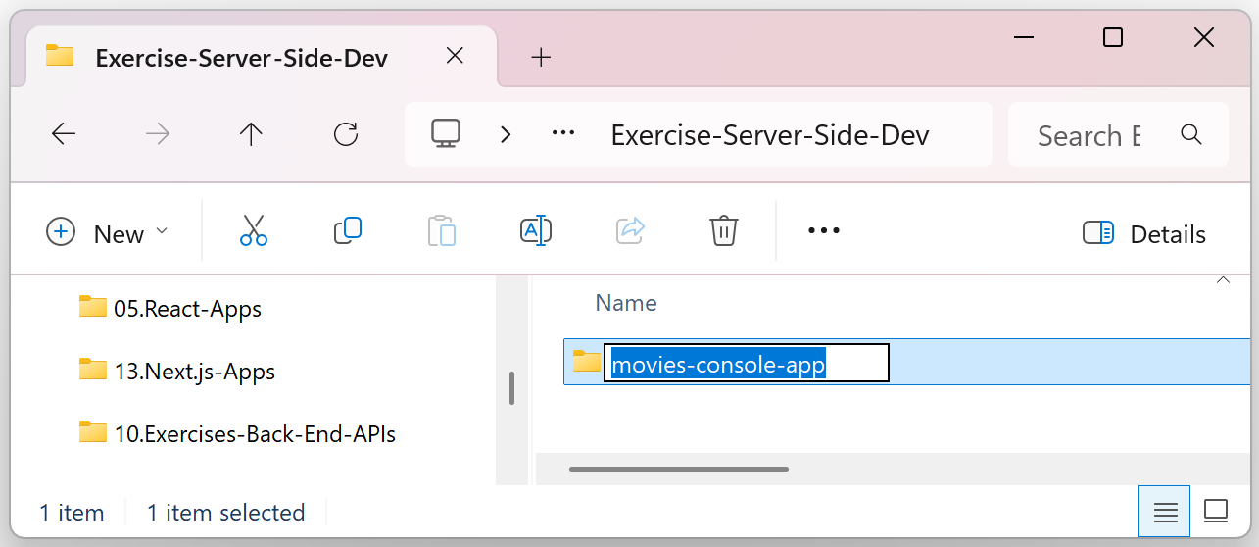
Open it in Visual Studio Code and initialize a new Node.js + TypeScript project:
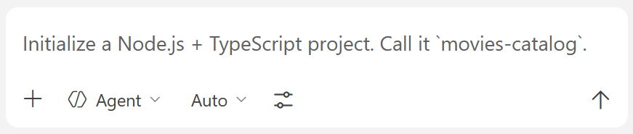

Step 2. Create a Neon DB

Create a New Neon Account
Create a Neon account (if you don't have). Open https://neon.com and click the [Sign up] button:
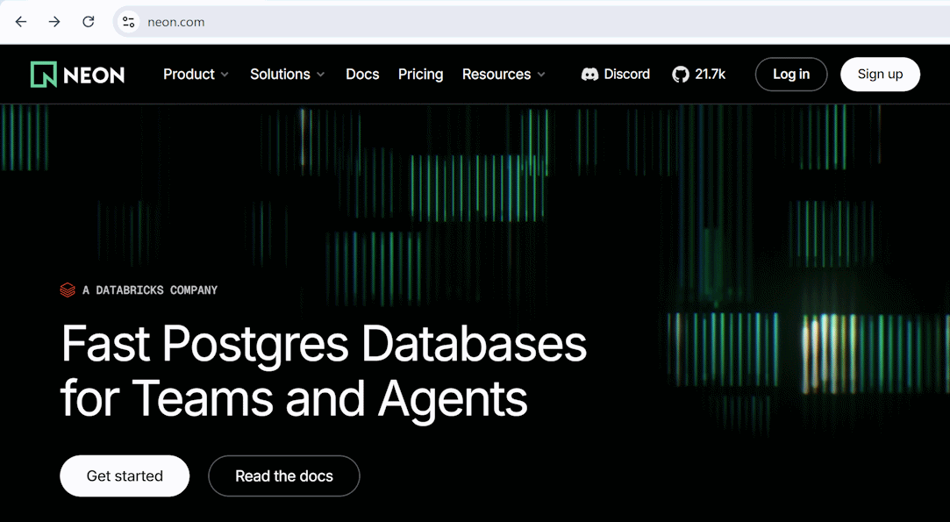
Then select a login method and enter the necessary details:
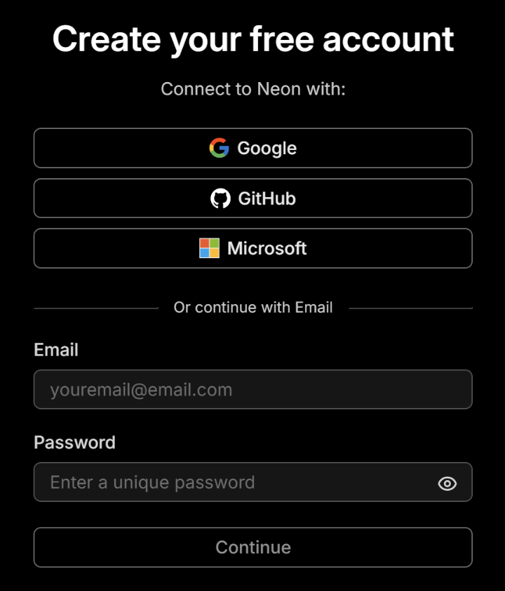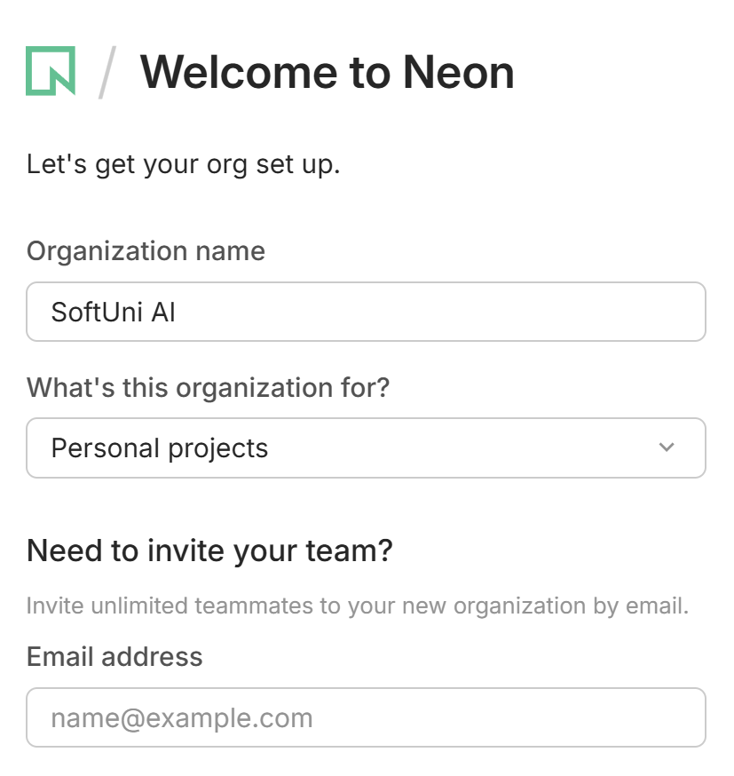

Create a New Neon Project
Create a new project and name it properly – e.g. `MoviesDB`:
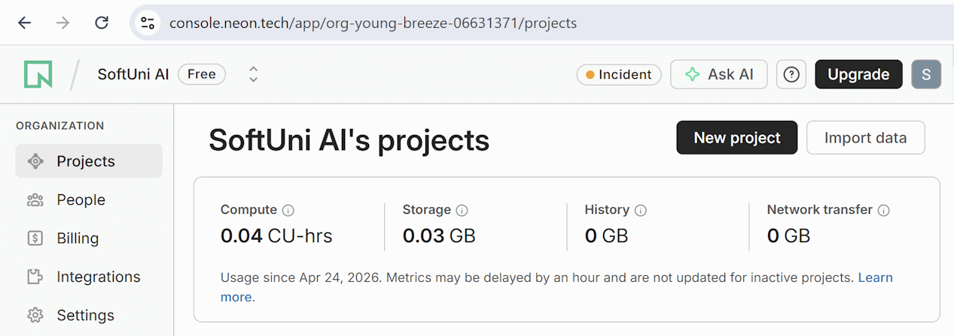
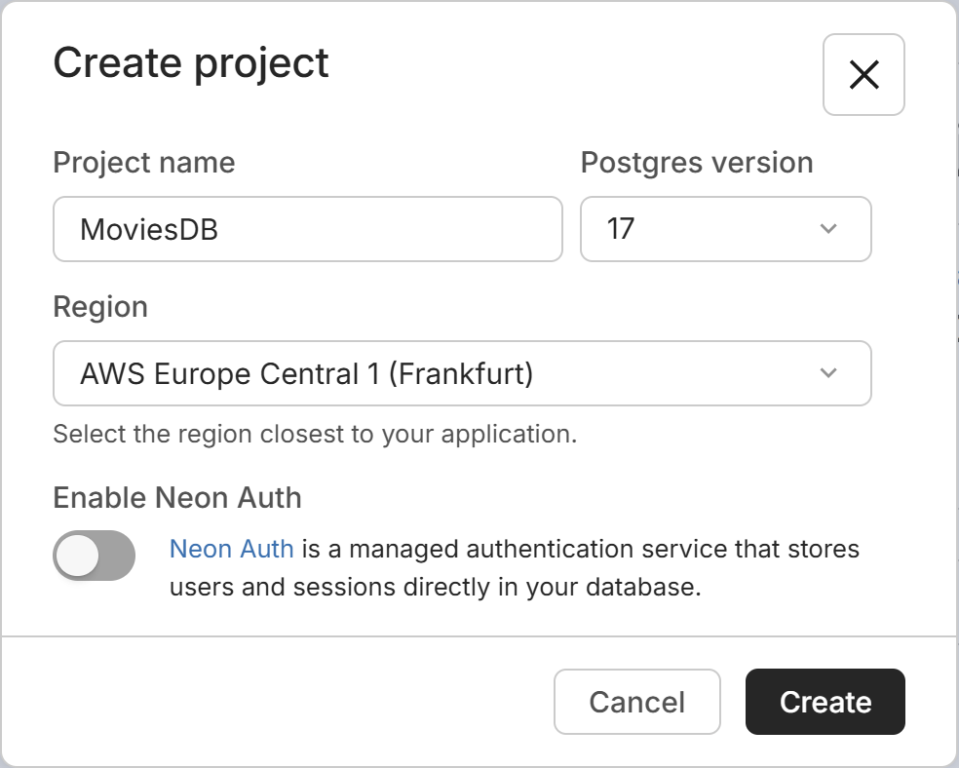

Step 3. Connect Neon MCP
Open the Extensions section in VS Code and type `@mcp neon` in the search bar. Select [Install in Workspace]:
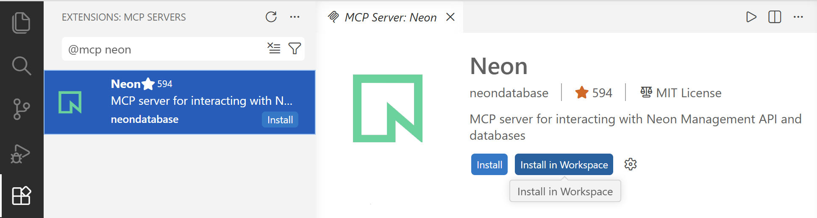
Then allow authorization of the MCP to your Neon account:
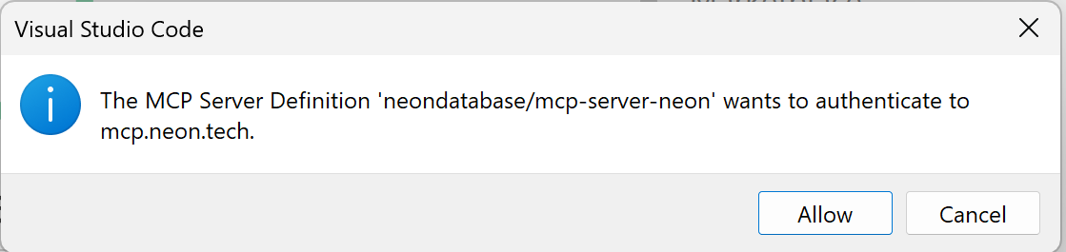
And open the link:
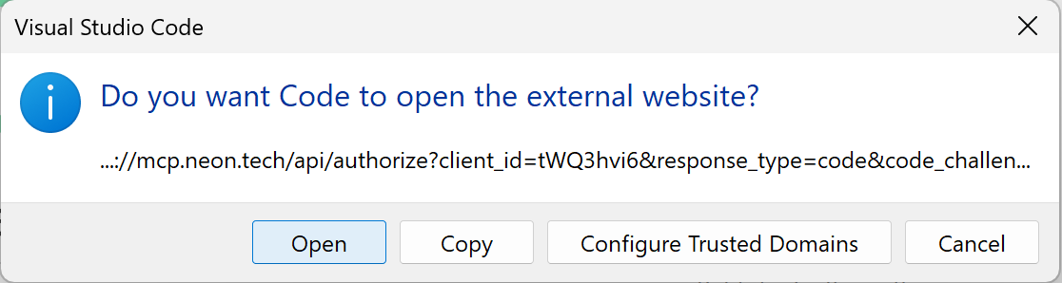
Add the Neon database name in `AGENTS.md` to avoid ambiguity when using Neon MCP. Use the following code:
# Neon MCP Database Access Rules:
- Connect Neon MCP only to a database project named `MoviesDB` in my Neon account.
Your AGENTS.md config may look like this:
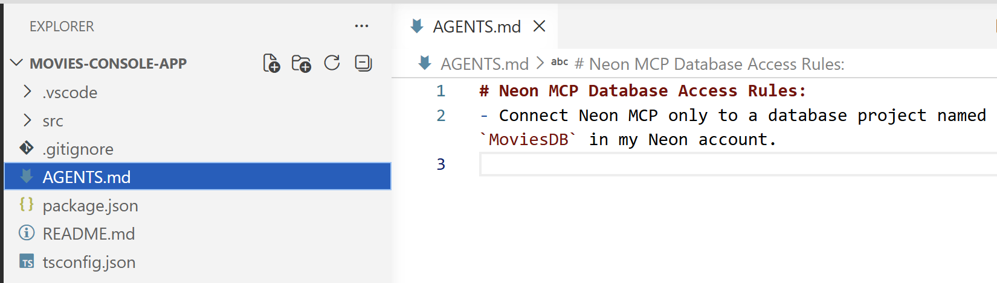
Test the MCP server. run `Show DB info` in the AI Chat:
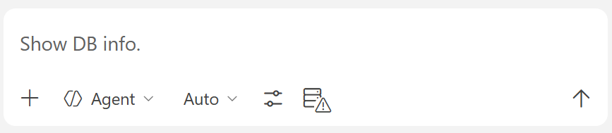
You should get some details about the Movies database:
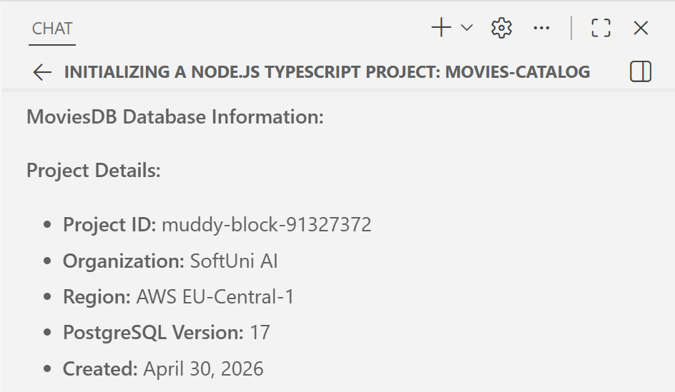
If the MCP is not properly configured, it will either not work or will ask you which Neon project to use (because Neon MCP is connected to your entire account with all your projects, no to a specific project).

Step 5: Install Drizzle ORM
Ask the AI dev agent to install Drizzle ORM and configure it with PostgreSQL:
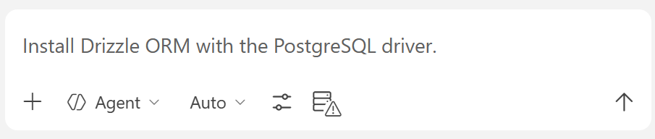
Configure Neon DB connection in your Node.js project (use Neon MCP):
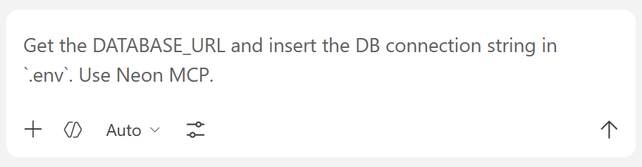
The goal is to have your database connection string properly configured in your project's .env file.

Step 6: Create DB Schema
Create a run a Drizzle migration to define the DB schema:
  - genres: id, name (unique)
  - movies: id, title, year, rating, genre_id (FK to genres)

Sample AI Prompt
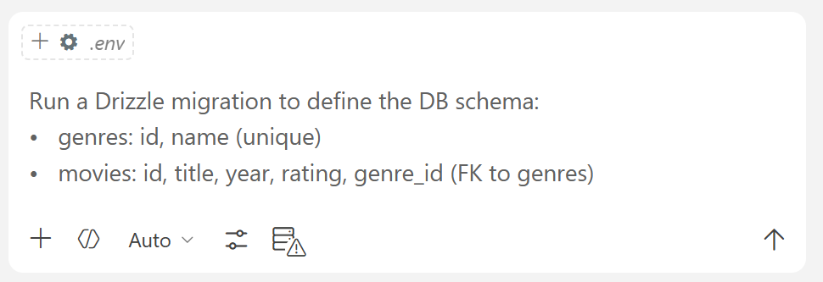

The Result: Migrations + Tables
The above prompt should perform several steps:
- Define your Drizzle schema file: db/schema.ts. This is the most important config file in Drizzle. It describes your tables, their columns, relationships between tables and other details about the database structure. The schema file is a TypeScript code, not SQL. This file is used to generate SQL at the next step.
- Run `drizzle-kit generate` to generate the migration as SQL script, based on your schema file and your earlier migrations. The output will be in the drizzle/ folder.
- Run `drizzle-kit migrate` to execute the SQL script in the database, while keeping metadata about the migrations applied. The migration should create 3 tables in the database: public.genres, public.movies and drizzle.__drizzle_migrations. These tables match the Drizzle schema and keep track of the migrations applied in the DB.
This is how your Drizzle migrations folder drizzle/ may look like in VS Code:
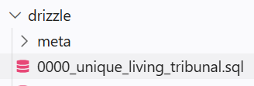
Finally, you can see your app's data tables in Neon. Click the [Tables] tab:
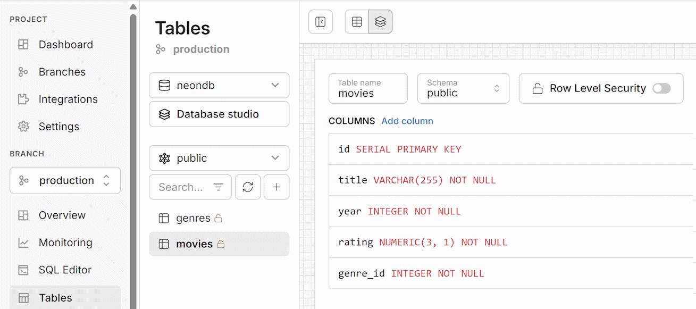

Step 7: Seed Sample Data in DB
Use the AI dev agent to seed sample data in the database:

Sample Prompt
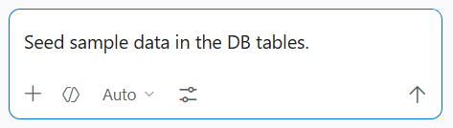
Typically, to seed sample data with Drizzle and Beon, the AI dev agents will create a seed script, e.g. db/seed.ts, which connects to the DB and inserts sample data rows in the tables. This logic is not SQL. It is JavaScript / TypeScript code, which uses the Drizzle API to insert sample data.
Typically, the seed script will be added as npm run target in package.json, so that you will be able to run it with a Terminal command like this: `npm run db:seed`.

The Result: Seed Script + Data in DB
After running the seed script, the Neon database will be populated with sample movie genres and movies:
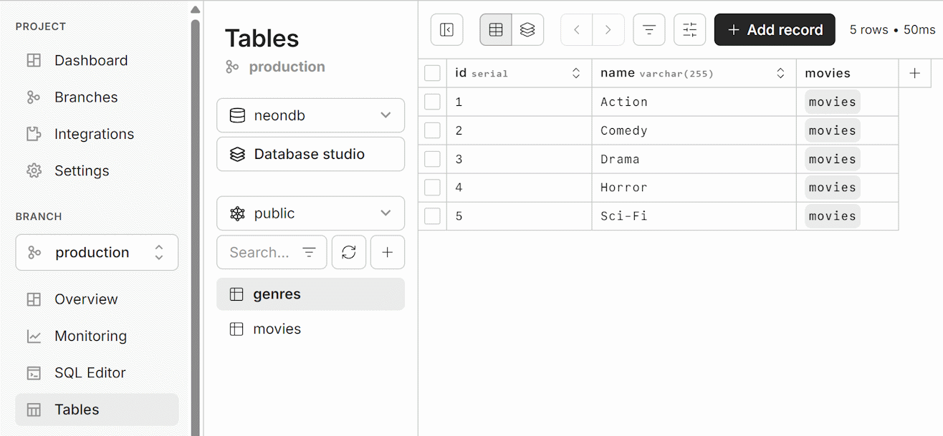

Step 8. Implement the App Functionality
Now we have the database, with sample data. It's time to implement the app logic. We want to implement data operations like these: list genres, list movies, list genres with movies in each genre, add / edit delete a genre, add / edit / delete a movie. For simplicity, the app UI will be console-based (no complex UI, no UI frameworks).
To implement the app logic, you can run an AI prompt like this:
- Implement a console app that prints all genres along with the movies in each genre.
  - Implement a simple console menu: list genres / list movies by genre / add a movie / delete a movie
  - Implement the requested database operations using a console-based UI

Sample AI Prompt
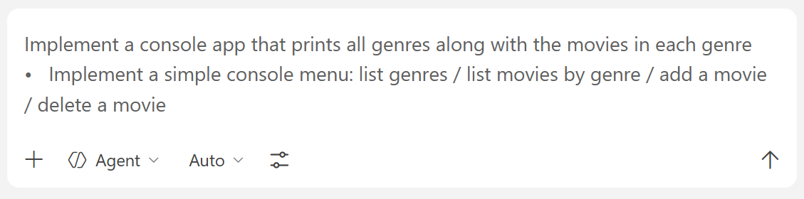
In the Terminal run the `npm run dev` command. You should be asked to choose an operation from a console-based menu:
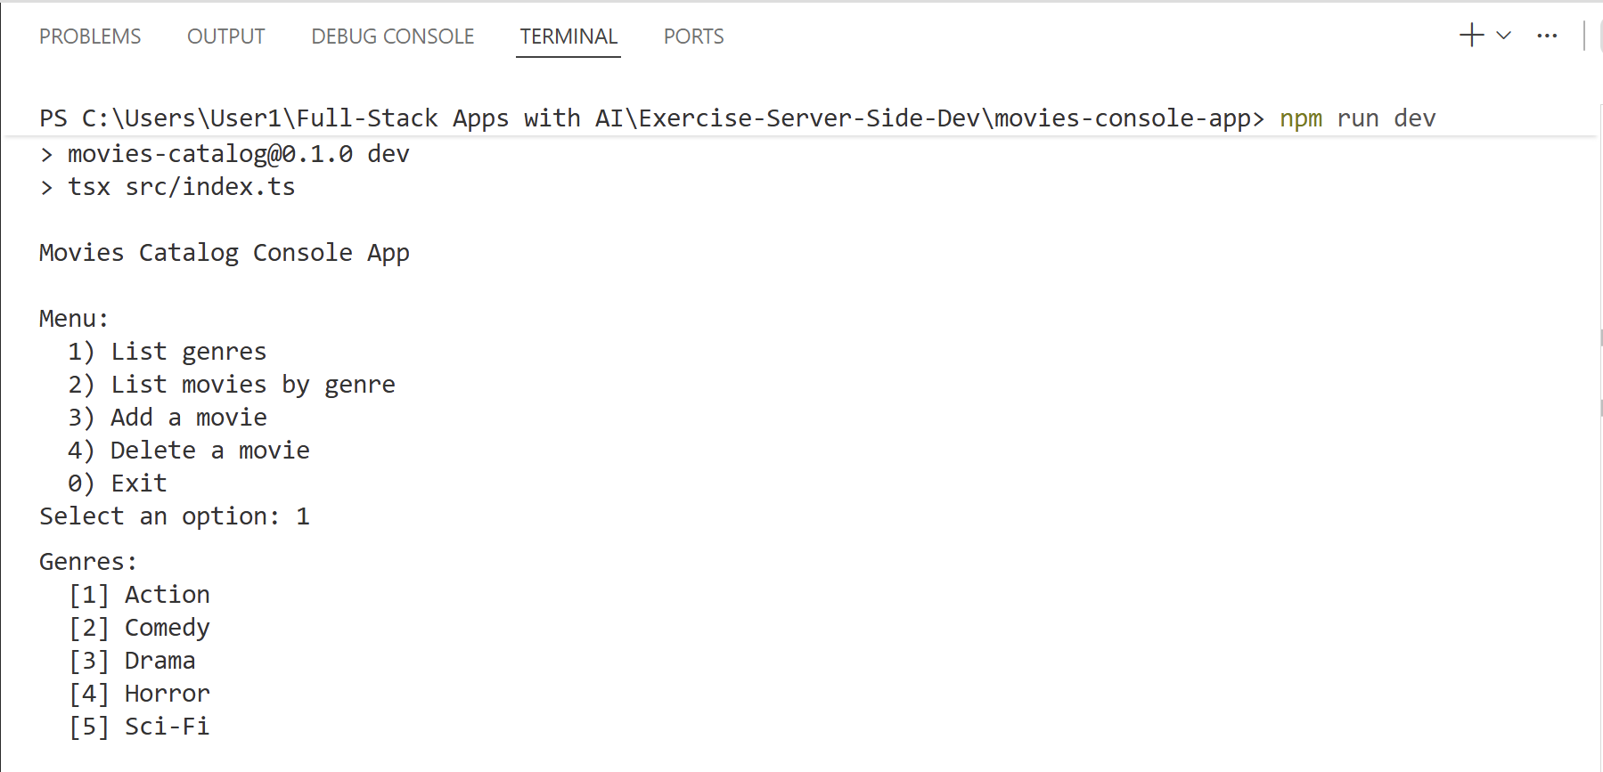
Test the Add/Delete functionalities:
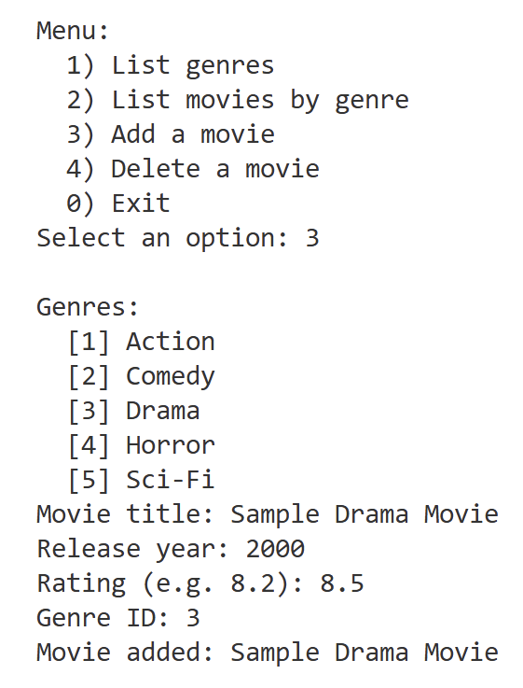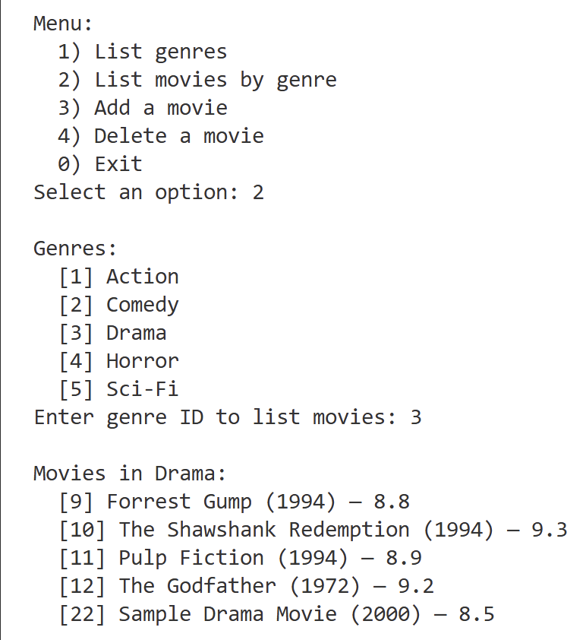

Jokes API Server
Build a minimalistic Jokes API server with Next.js + Drizzle ORM + PostgreSQL (Neon):
  - The Jokes API will manage a set of jokes (CRUD operations, without auth)
  - Keep app data in a Neon DB (no auth, no users)
    - Configure Neon MCP to access the correct database in Neon
    - Jokes have: id, title, text, category, publish date
    - Use Drizzle migrations to define and create the DB schema
    - Seed sample data: 10-15 jokes across different categories
  - Implement the following API operations (without authentication):
    - Get a random joke
    - List all jokes (with paging)
    - List jokes by category
    - Get a joke by id
    - Publish a new joke
    - Edit a joke
    - Delete a joke
  - Generate a small home page, which documents briefly the API endpoints
  - Test the Jokes API endpoints with Postman

Step 1. Create VS Code Workspace
Create a new workspace for your app, e.g. `jokes-api`, and open it in VS Code.

Step 2. Setup Next.js Project
Initialize a new Next.js + TypeScript project, with Drizzle and Neon libraries.
You can doe it by hand or with and AI prompt:
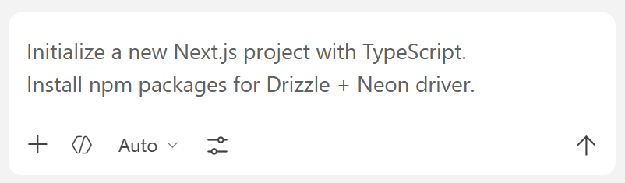
Your AI dev agent will create a new Next.js project (either manually or using `create-next-app` CLI). It will setup the basic project files and folders and will initialize the package.json config files, with the required npm libraries.

The Result
This is how your new empty Next.js project may look like in VS Code:
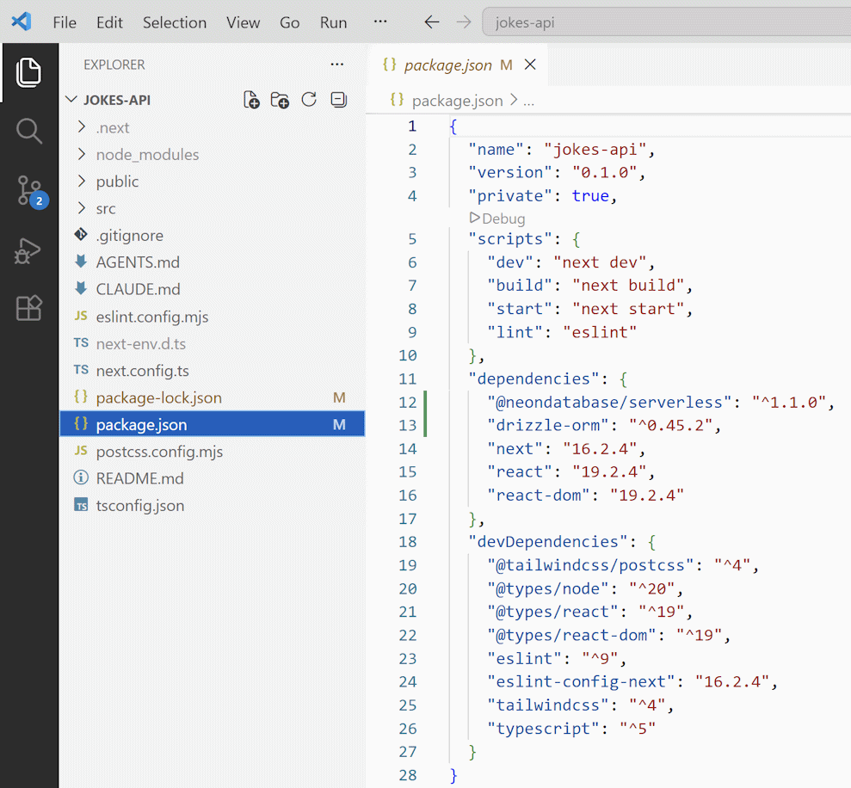

Step 3. Setup Neon DB and Neon MCP
Now, let's go ahead with the database. Create a new project in Neon and name it properly, e.g. `JokesDB`.
Install Neon MCP in the workspace by typing `@mcp neon` in the Extensions Search Bar in VS Code. Put additional instructions in the AGENTS.md file to tell the AI agents which Neon DB to use (because you have several in your account):
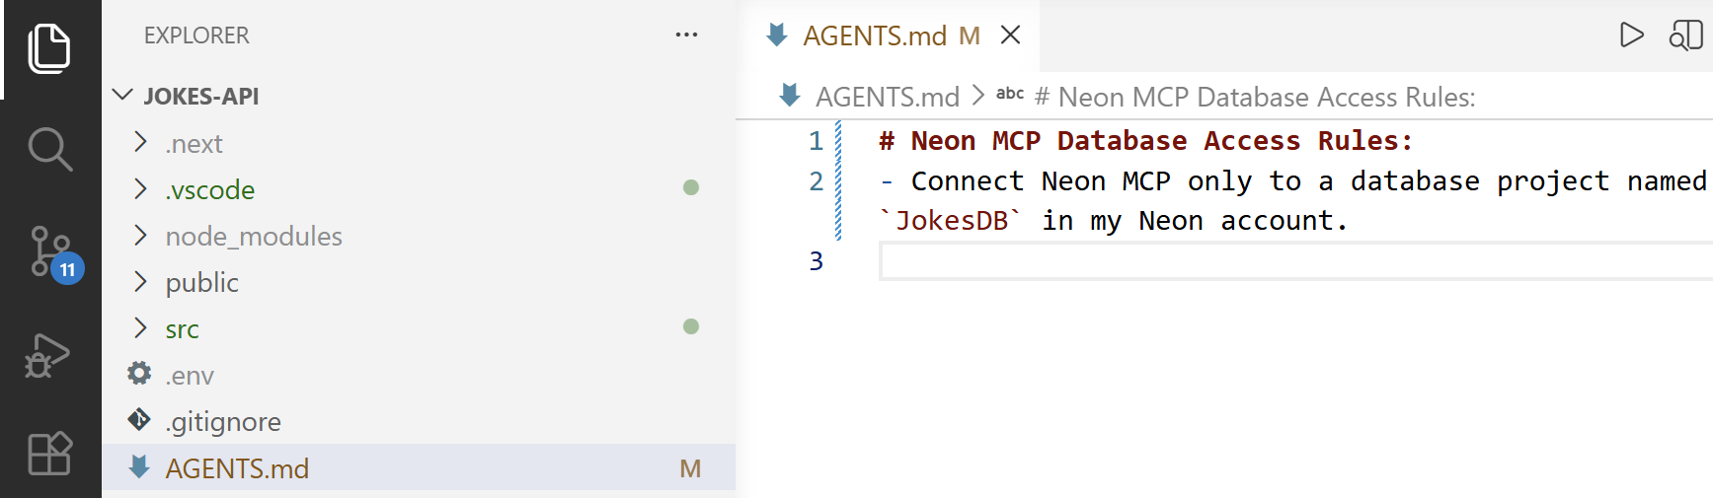

Step 4: Connect to Neon DB
Now, let's configure Next.js with Neon DB. You will need a DB connection string in the `.env` file.

Sample AI Prompt
When Neon MCP is configured properly, this can be done by AI prompt:
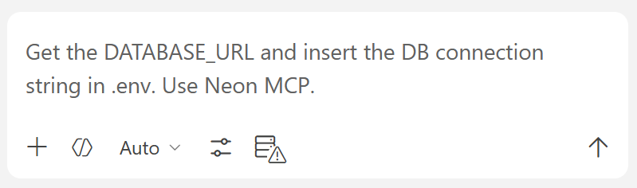

The Result: Database Connection String
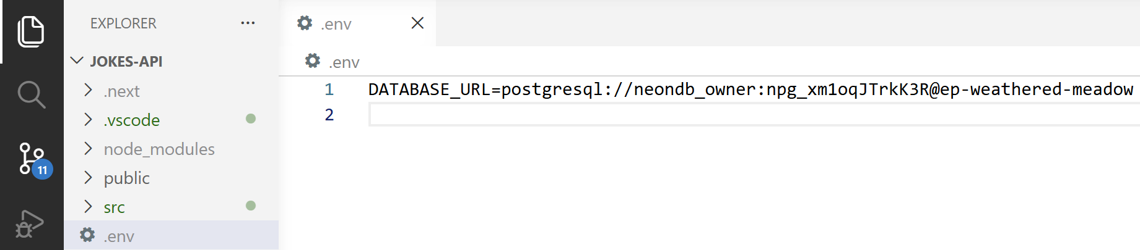

Step 5. Create DB Schema and Seed DB

Define the DB Schema
Ask the AI dev agent to define the DB schema with two tables – categories and jokes:
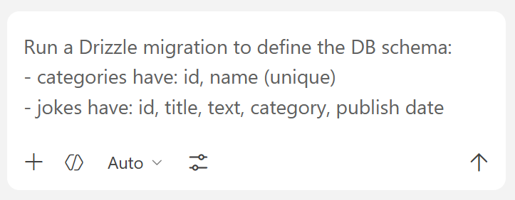
Use Drizzle migration (not a direct SQL in the DB).

The Result: Migrations + DB Tables
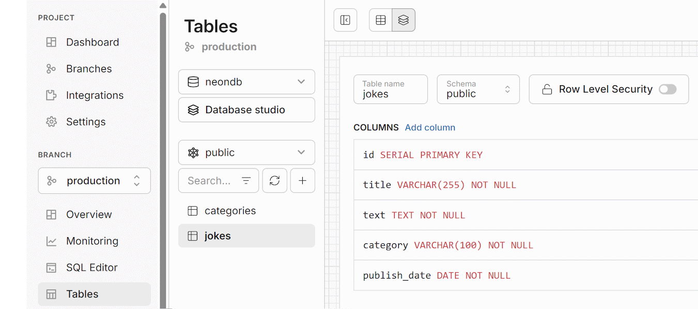

Seed Sample Data
Create and run a seed script to generate sample data in the DB for testing:
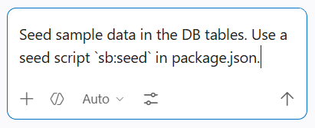

The Result: Seed Script + Data in DB
Finally, you will have sample data in your tables in the DB:
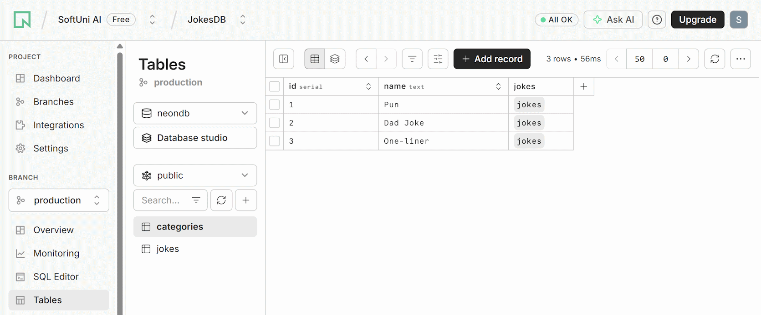

Step 6. Implement the API
Now we have the DB configured and functional. It's time to implement the Jokes API.

Sample AI Prompt
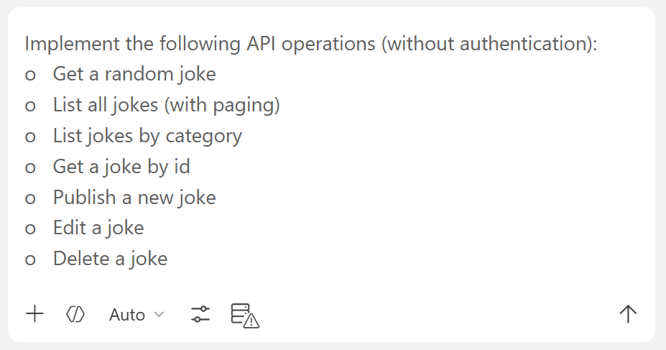

Step 7: Generate API Docs
Generate a small API documentation home page, which documents briefly the API endpoints.

The API Docs in the Browser
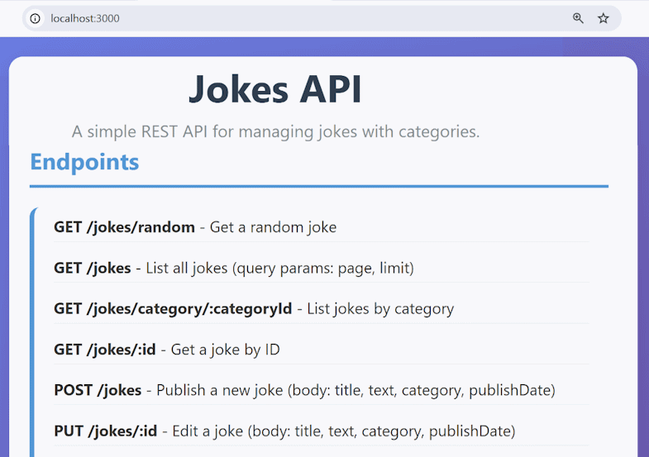

Step 8: Test the API with Postman
Run the `npm run dev` command to start the RESTful API. Use Postman to test the API endpoints.

Organizing Postman
Create a new Postman collection for this exercise (e.g. `Lecture 12 – Jokes API`) and create folders inside where requests will be stored – e.g. [GET] folder for all [GET] requests:
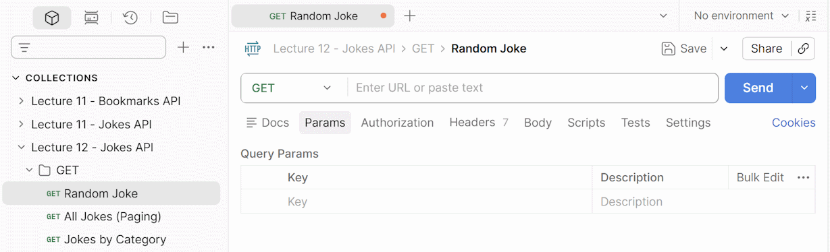

Test 1: Get a Random Joke
Take the "Random Joke" API endpoint from the documentation homepage and paste it together with the URL of the local server in Postman:
GET http://localhost:3000/jokes/random
Send the request. If you get a [200 OK] code, the API endpoint works.
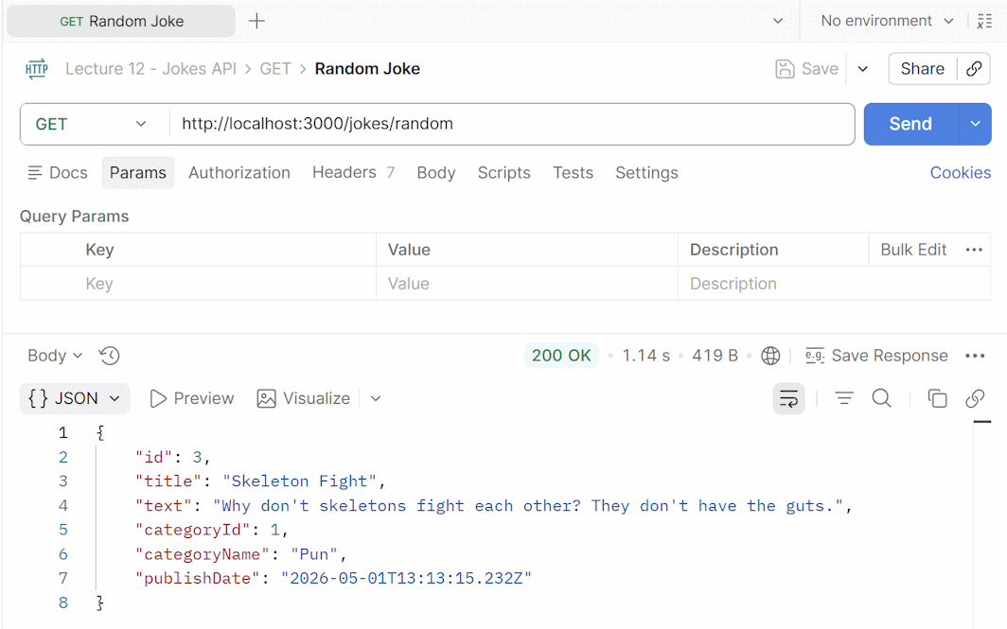

Test 2: List All Jokes with Paging
Run the following HTTP request:
GET http://localhost:3000/jokes?page=1&limit=2
The request will return page 1 of the whole paginated list with jokes and a single page may contain a maximum of 2 jokes. If you want to see the next 2 in the row, request page 2 or expand the limit to more jokes per page.
GET http://localhost:3000/jokes?page=2&limit=2
You can try also other paging slices:
GET http://localhost:3000/jokes?page=1&limit=5
If the slice is non-existent, the result will be empty:
GET http://localhost:3000/jokes?page=2000&limit=500
This is a sample result from the Jokes API in Postman:
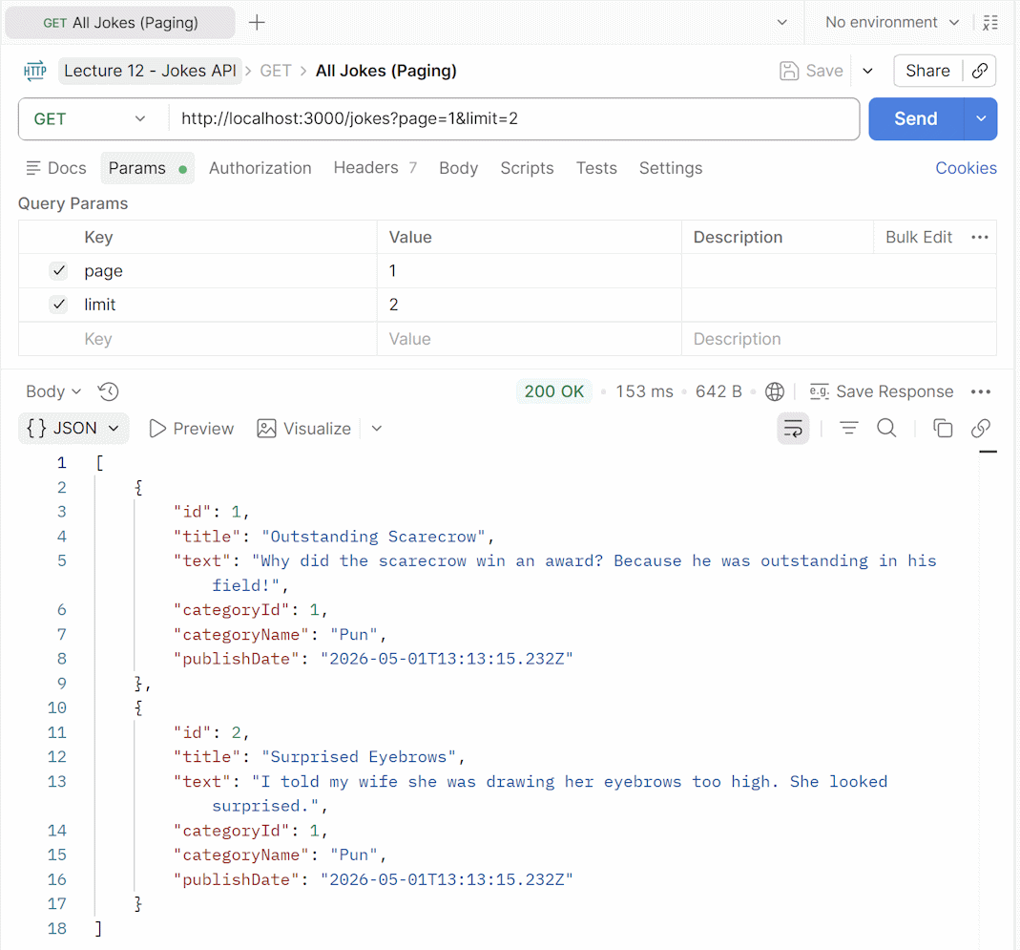

Test 3: List Jokes by Category
Run the following HTTP request:
GET http://localhost:3000/jokes/category/3

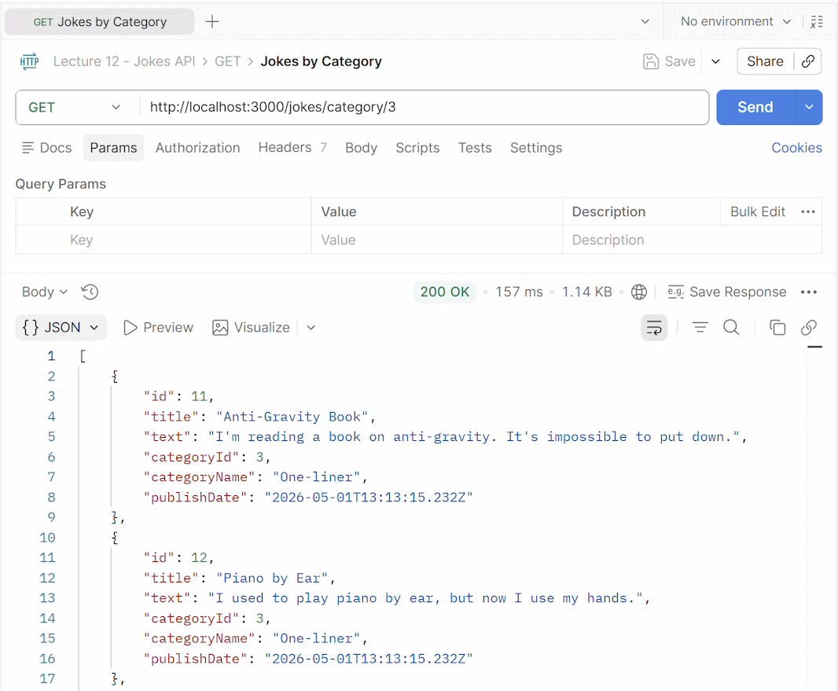

Test 4: Publish a New Joke
Ask the AI dev agent in VS Code to generate a HTTP request body for creating a new joke:
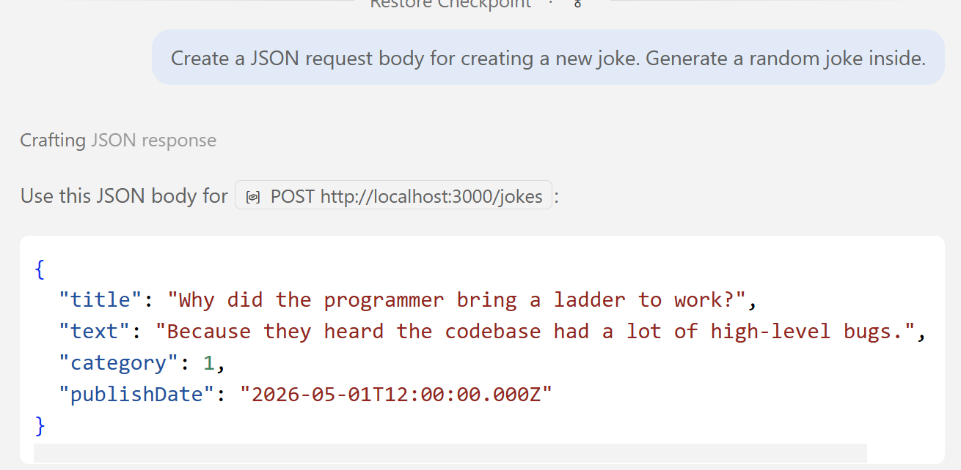
Use HTTP POST request with the `jokes` endpoint:
POST http://localhost:3000/jokes
Paste the AI-generated JSON in Postman: Request -> Body -> raw -> JSON:
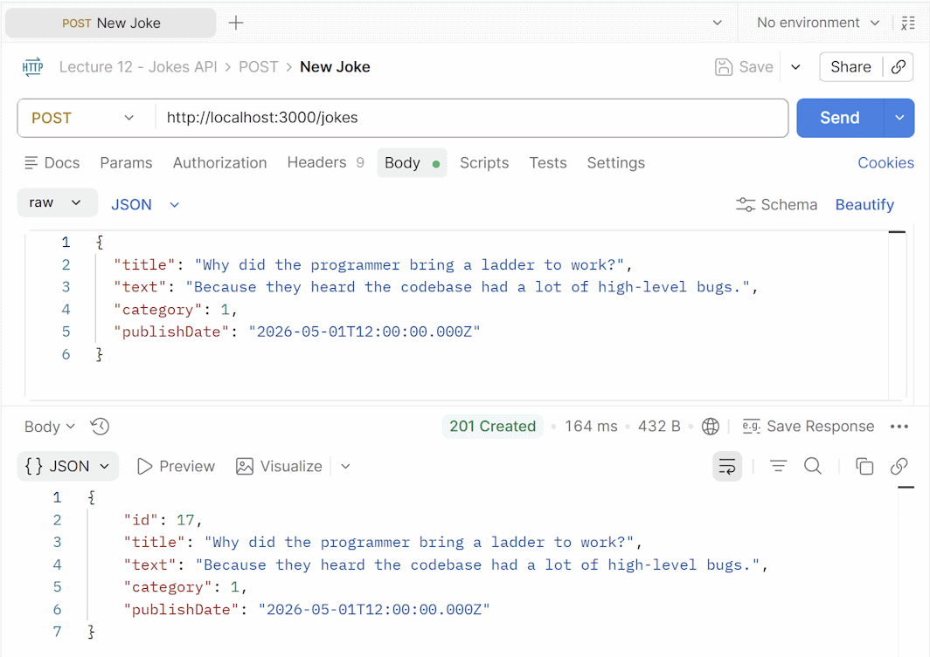
Select [POST] for request and add the URL:


Recipes API
In this exercise we shall build a Recipes API with Next.js + Drizzle ORM + PostgreSQL (Neon). This is the functionality to implement:
  - Anonymous visitors view recipes
  - Users register / login and create / edit / delete own recipes
  - Use Next.js API, with PostgreSQL hosted in Neon with Drizzle ORM
  - Implement authentication with standard JWT tokens

Step 1. Setup a Next.js Project

Create a New VS Code Workspace
Create a new workspace in VS Code for your app, e.g. `recipes-api`.

Initialize a Next.js Project
In the Terminal, run the `npx create-next-app@latest` command to initialize a Next.js project:
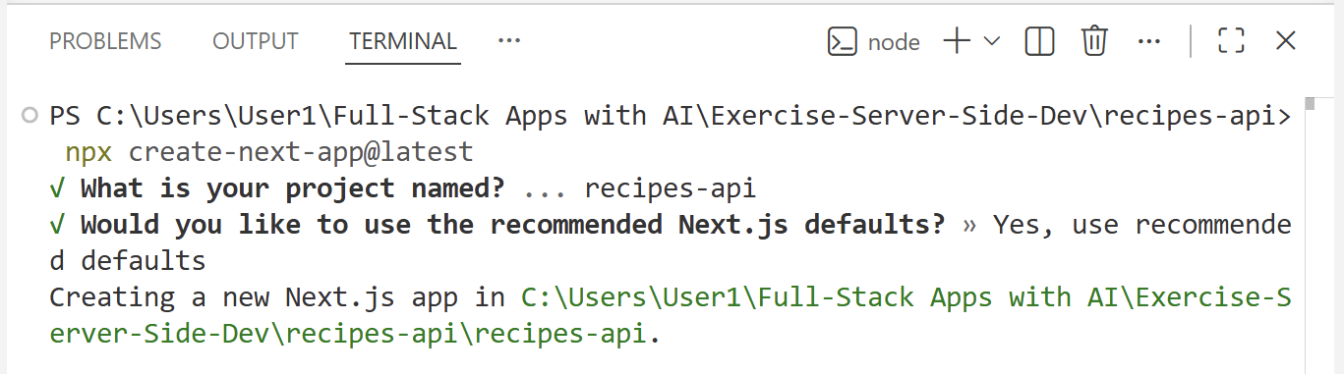

Install Drizzle ORM
Install Drizzle ORM + Neon DB driver + bcrypt + jsonwebtoken with a prompt. This will install a few npm packages.

Step 2. Set Up Neon Database
  - Create a new Neon DB project: `RecipesDB`.
  - Connect Neon MCP: VS Code --> Extensions --> Search --> `@mcp neon` --> Install in Workspace --> Authorize Neon MCP Server
  - Add the Neon database name in `AGENTS.md`
  - Configure Neon DB connection: insert the DB connection string in `.env`

Step 3: Define the DB Schema
Run an AI prompt to define the DB schema using Drizzle migration. Describe the tables required for your app: users and recipes.
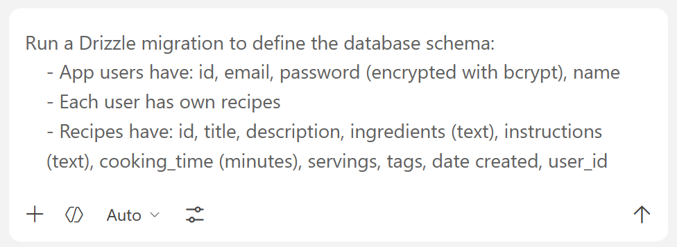

The Result: Migrations + DB Tables
As a result, we shall have a Drizzle schema + Drizzle migration scripts + data tables in the DB:
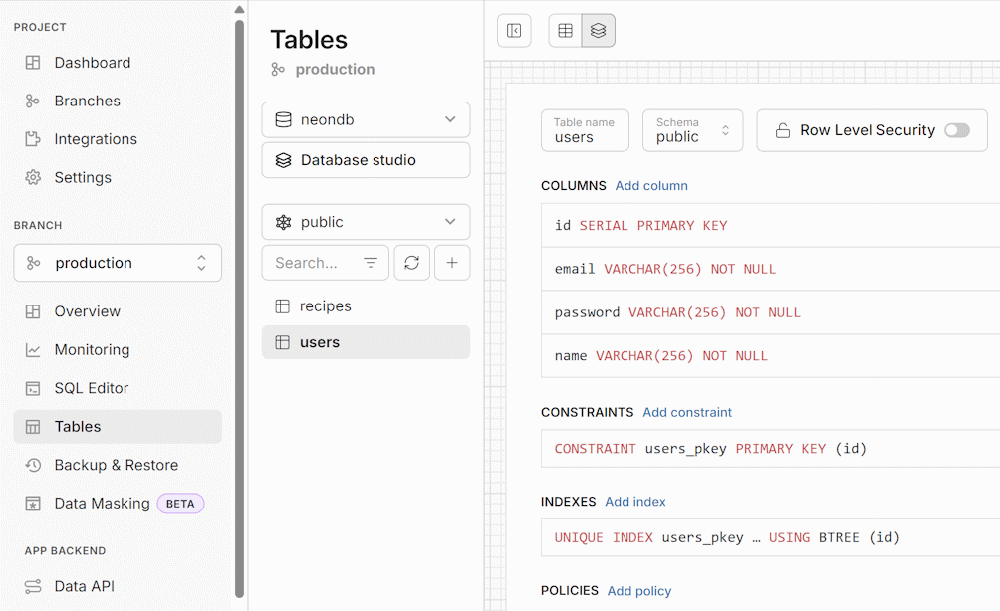

Step 4: Seed the Database
Now, let's seed sample data in the DB tables:

Sample AI Prompt
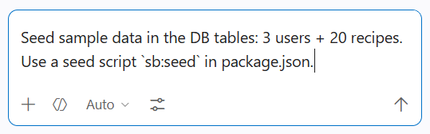

The Result: Data in DB
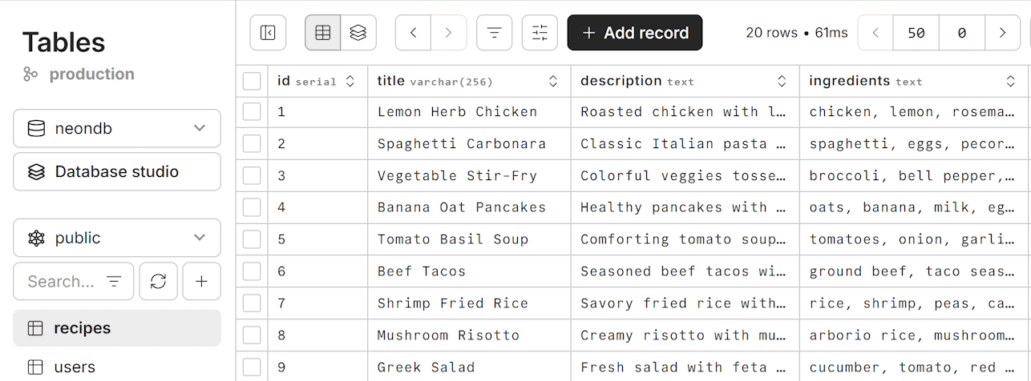

Step 5. Build the RESTful API
Now we have the database schema + tables + tables data, configured with Drizzle ORM.
Let's build the RESTful API with Next.js for our Jokes app, based on this database. Use an AI prompt like this:
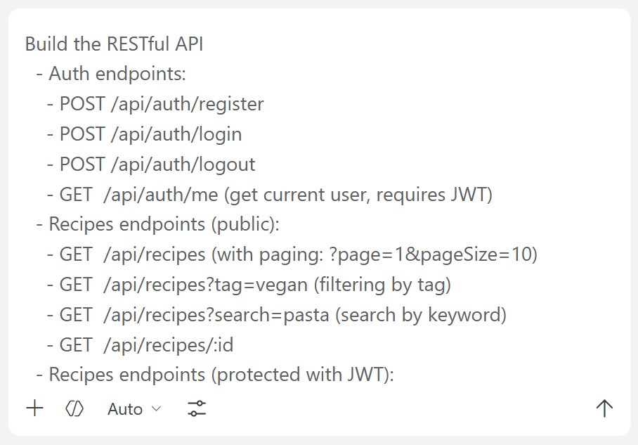

Step 5: Create the API Docs Page
Generate a simple API docs home page, which documents briefly the API endpoints.
Run the `npm run dev` in the Terminal command to start the Next.js app and see the result:
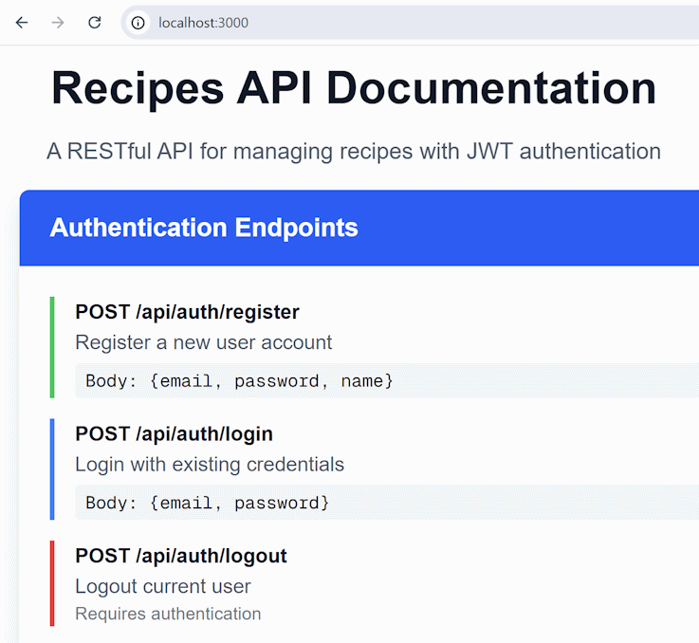

Step 6: Test the Recipes API
Create a new collection in Postman for this exercise, organize it and test the Recipes API endpoints:
  - List public recipes (without auth)
  - Register a new user
  - Login --> get a JWT token --> create a recipe
  - List all recipes, list own recipes
  - Edit existing recipe (owned by the same user)
  - Delete existing recipe (owned by the same user)
  - Try to edit another user's recipe --> should fail

Test 1: List All Recipes
Let's start the testing of Recipes API by listing the public recipes. This is the HTTP request:
GET http://localhost:3000/api/recipes
This is the expected request and response in Postman:
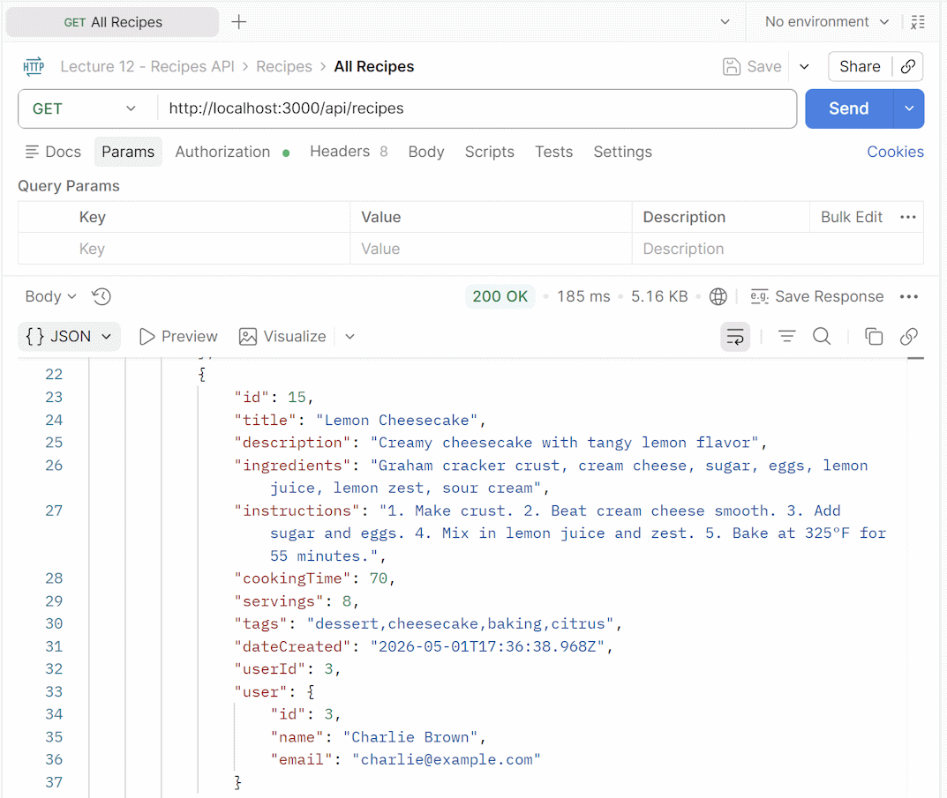

Test 2: User Registration
Register a new user with a [POST] request. The URL of the local server + the API endpoint for registration from the documentation. You can ask the AI dev agent to generate the HTTP POST request with JSON request body or create the request by hand. This is how the request may look like:
POST http://localhost:3000/api/auth/register
{
"email": "test@email.com",
"password": "testPass1",
"name": "Test Name"
}
If the API server works correctly and the request is correct, the response should be [201 Created]:
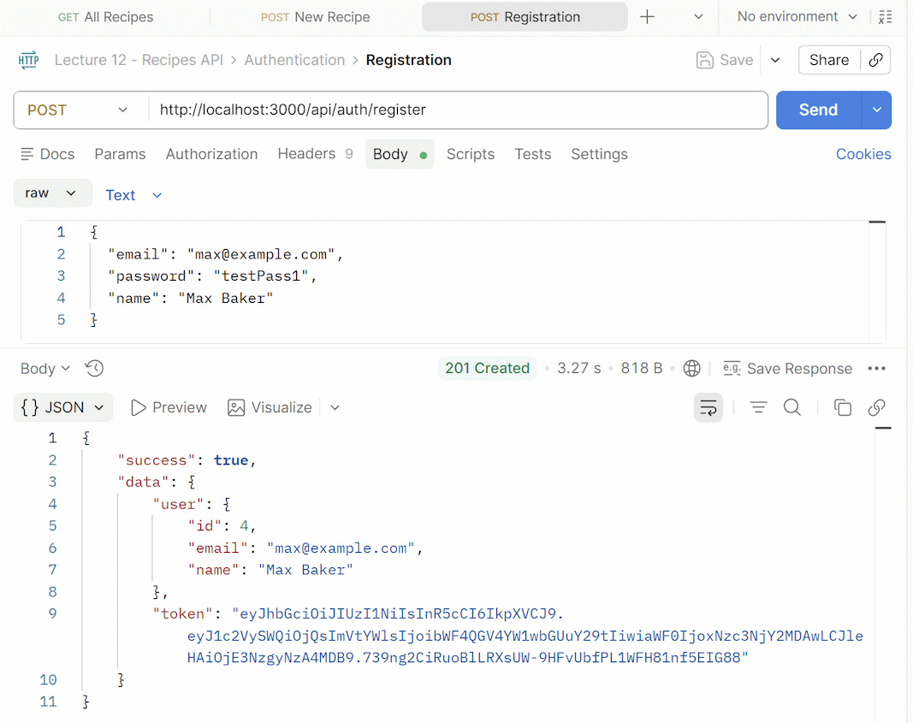

Test 3: User Login
To login a user, we should use a POST request, as well. Add the API endpoint URL in the request box. Then, in the [Body] section, enter the email + password of the user which was just registered. Use a JSON request body:
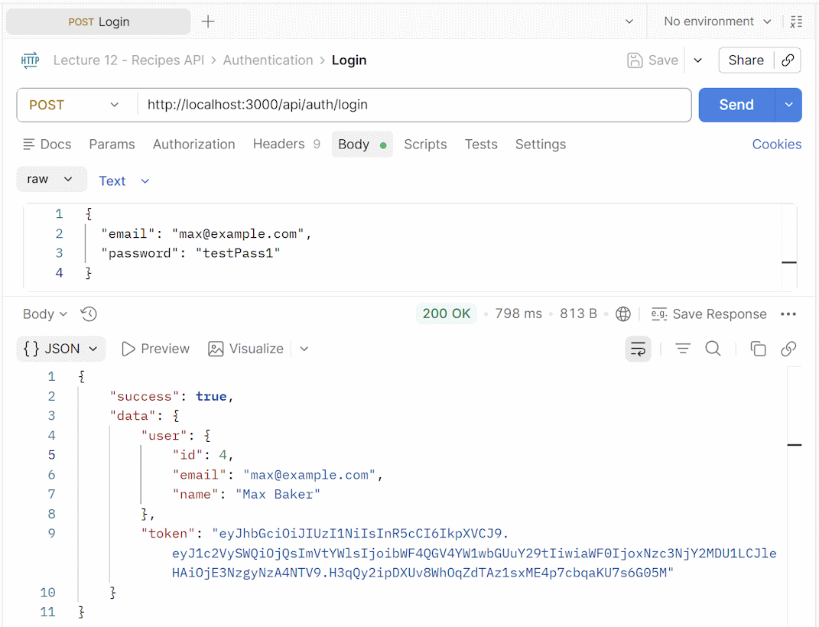
Save the returned JWT token from the HTTP response. It’s needed for the following tests.

Test 4: Create a Recipe for User
Post a new recipe for the specific user that was just registered. Go to [Authorization], select [Bearer Token] and paste the token that was copied there. Now you are logged in as this specific user. This is how the HTTP POST request for creating a recipe may look like:
POST http://localhost:3000/api/recipes
Authorization: Bearer <JWT_token>
{
"title": "Spicy Mango Chicken Bowl",
"description": "Grilled chicken served over rice with a sweet and spicy mango glaze.",
"ingredients": "chicken breast, mango, soy sauce, honey, lime juice, garlic, ginger, rice, cilantro",
"instructions": "Marinate chicken, grill until cooked, prepare mango glaze, serve over rice with cilantro.",
"cookingTime": 30,
"servings": 2,
"tags": "chicken,spicy,sweet,salad,bowl"
}
Let's send this request with Postman:
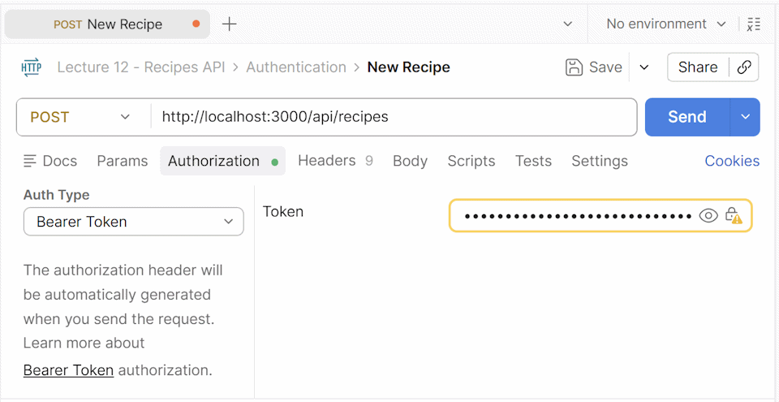
Then click the [Body] tab and paste a JSON-formatted recipe details:
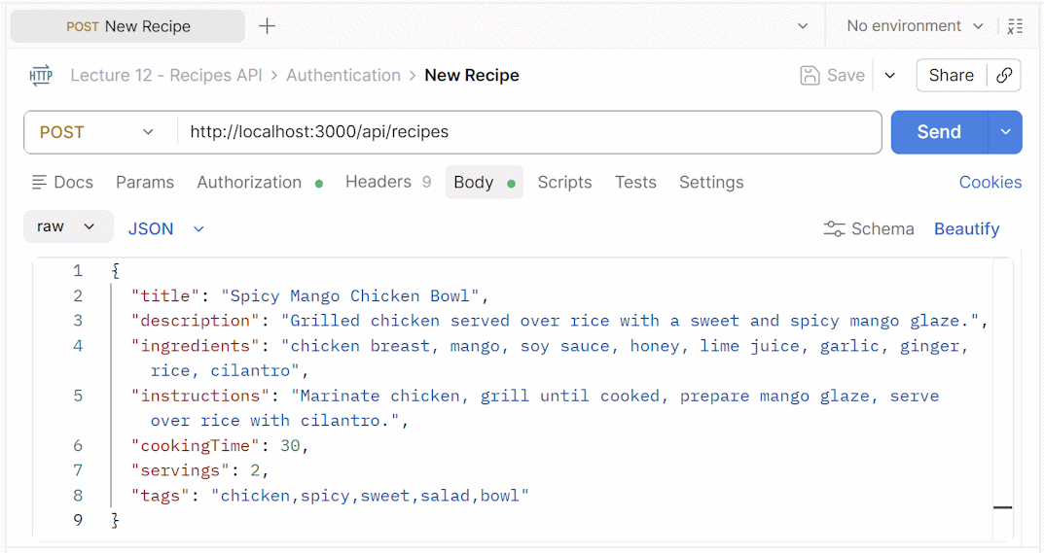
This is how the entire HTTP request + response will look like for a successful addition of a recipe, with JWT authentication:
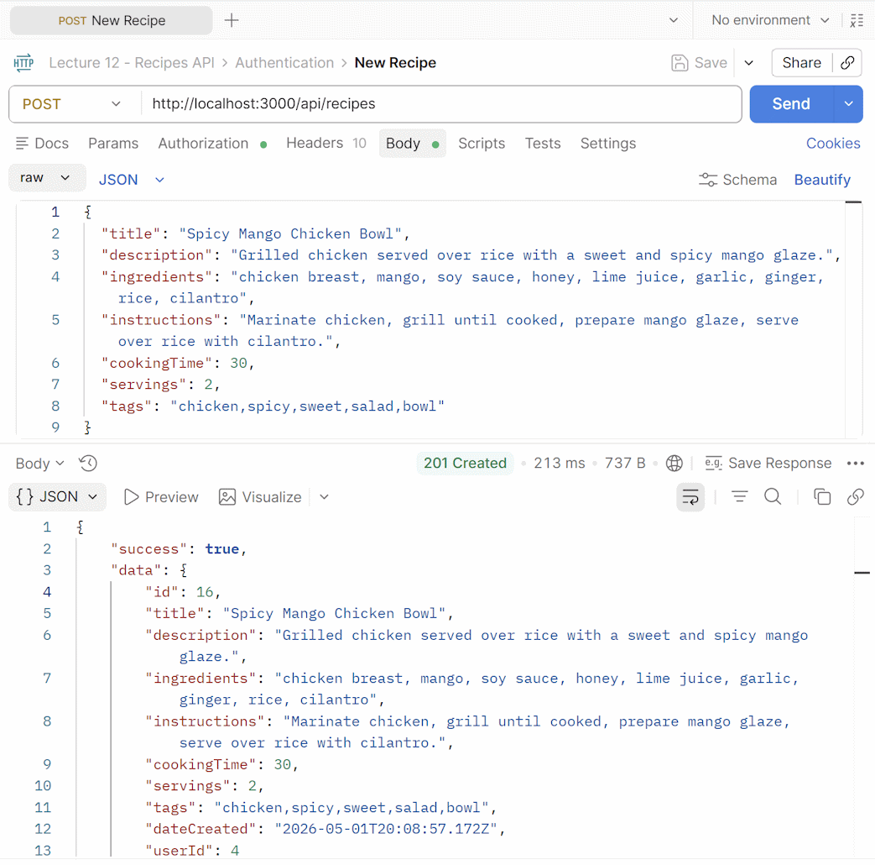

Test 5: List Own Recipes
While logged in, try to list your own recipe with a simple [GET] request with the API from the documentation. You should be able to see only the recipes you have added. This is the HTTP request:
GET http://localhost:3000/api/recipes/my
Authorization: Bearer <JWT_token>
This is a sample of successful request execution in Postman:
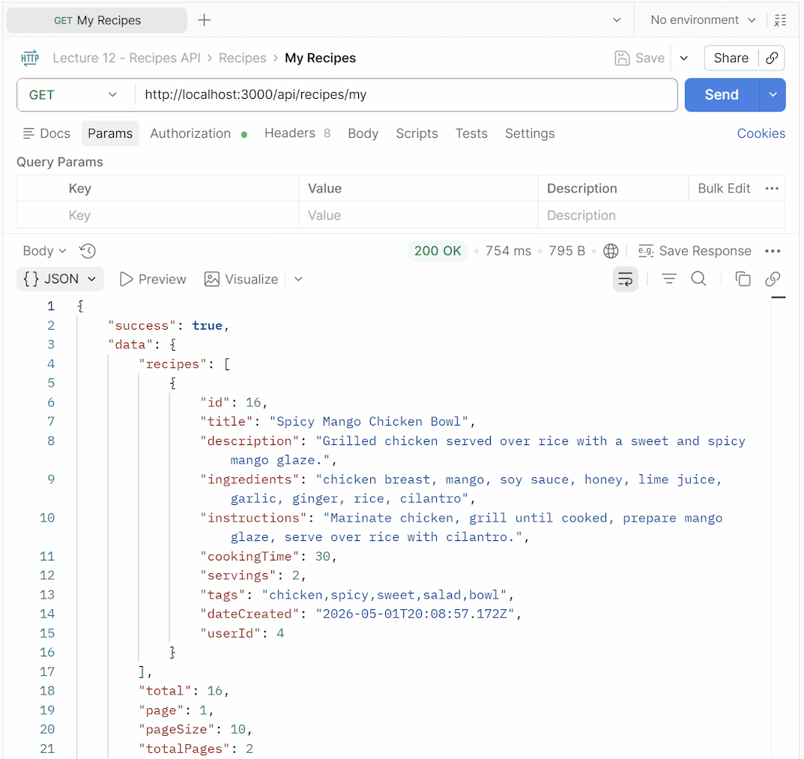

Test 6: Edit Existing Recipes
Let's test "edit recipe" endpoint.

Recipe by the Same User
To edit a recipe its owner, make sure the user is logged in (the token is in Authentication header). Put the JSON you used for adding the recipe and edit a small detail. In the example below, the meal cooking time was edited from 30 to 35 minutes. Use the [PATCH] request:
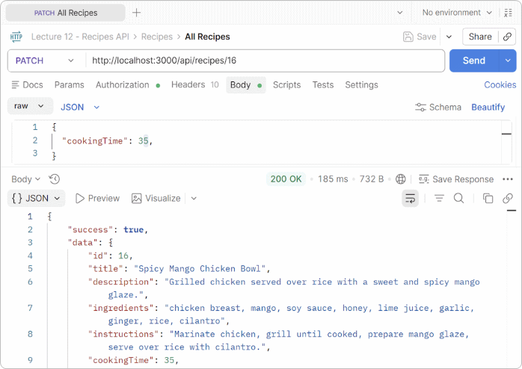

Recipe by Unauthorized User
The user should be able to edit only their own recipes and get an error if they try to edit another user’s recipe:
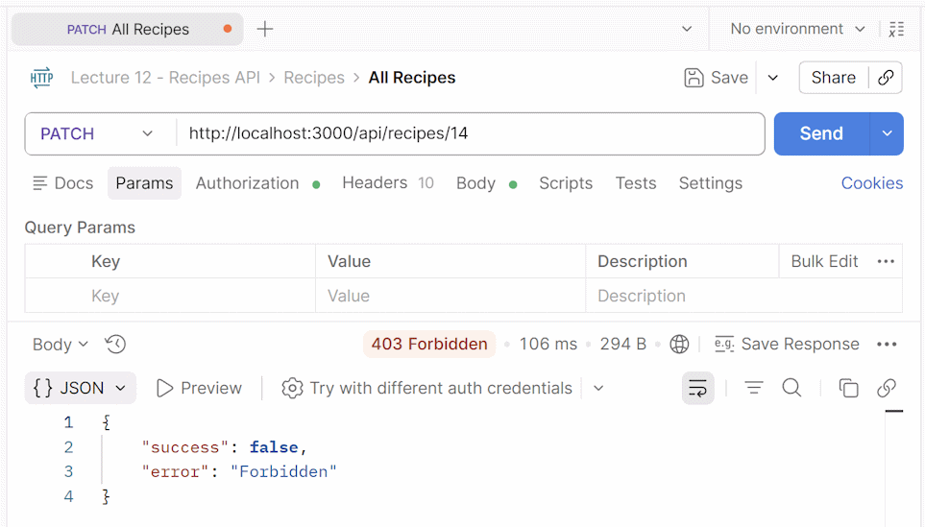

Test 5: Delete an Existing Recipe
This should be allowed only for users who want to delete their own recipes:
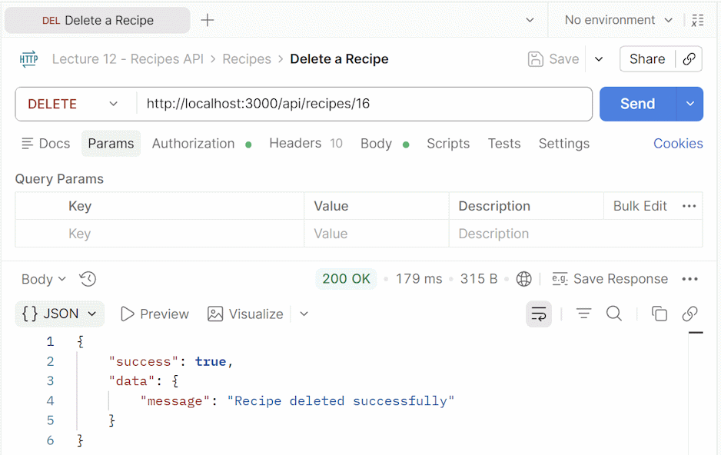

Recipes Client App
Now we have the Recipes API, with users, authentication, database persistence, implemented and tested. Now let's build a front-end client app, which uses the API and implements UI for the end users.
Implement a Recipes client app with Next.js and React:
  - Anonymous users can:
    - Browse recipes on the home page (with paging and a search bar)
    - View recipe details (full version)
    - Filter recipes by tag
    - Register and login
  - Logged-in users can:
    - Browse and view recipes
    - View "My Recipes" page
    - Create / edit / delete own recipes
  - Use the existing Next.js API endpoints
  - Use Tailwind CSS for styling
  - Split the pages into simple modular components (avoid large files)
  - Add a link to the API docs page (instead of deleting it)

Sample AI Prompt
We can use the above app description as an AI prompt to build the app.
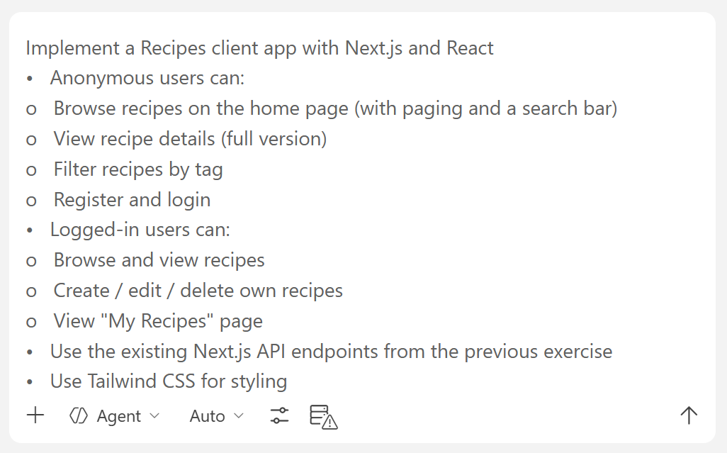
We shall not explore the details about building the client app, because in this lesson the focus is on building APIs with Drizzle and Neon. We shall learn about building UI with Next.js later.

The App in the Browser
The app may look like this:
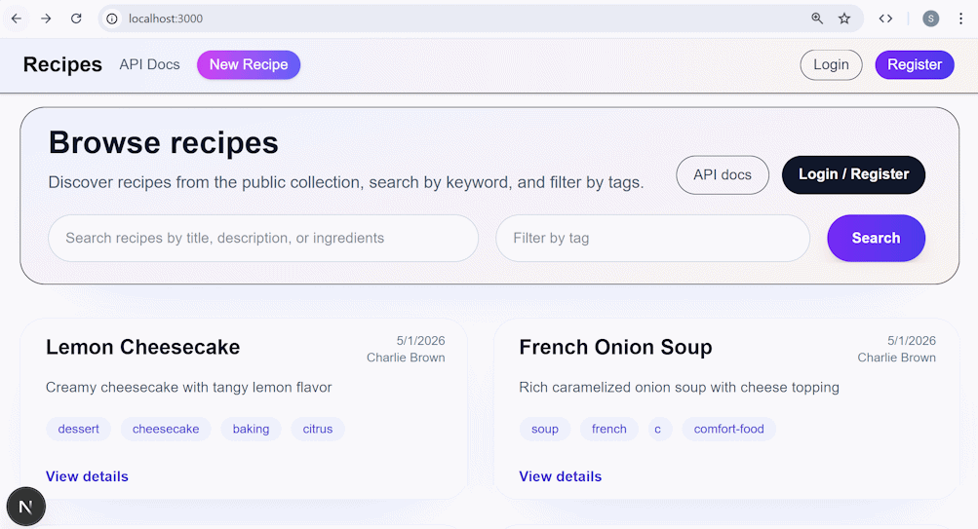

Recipe Photos
Now, let's extend the Recipes app to support cover image uploads for recipes. We should store image uploads in an object storage service like Cloudflare R2, Amazon S3, or Supabase Storage. We chose Cloudflare R2, because it is highly reliable storage service, with generous free plan. Let's go through the steps to register, create a storage bucket, get API keys, and upload / download files from TypeScript code.

Step 1. Setup Cloudflare R2
Create a Cloudflare account:
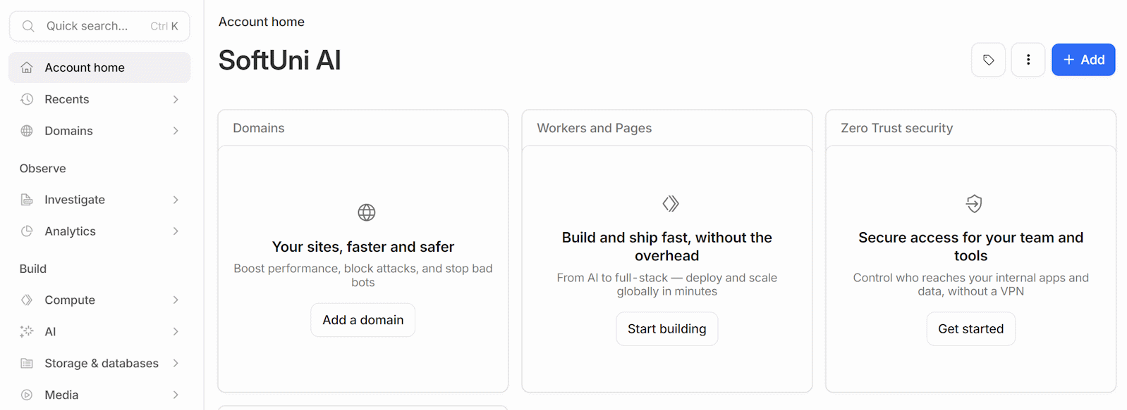
Go to Cloudflare -> Storage and Databases -> R2 Object Storage -> Overview -> click the [Add R2 subscription to my account] button:
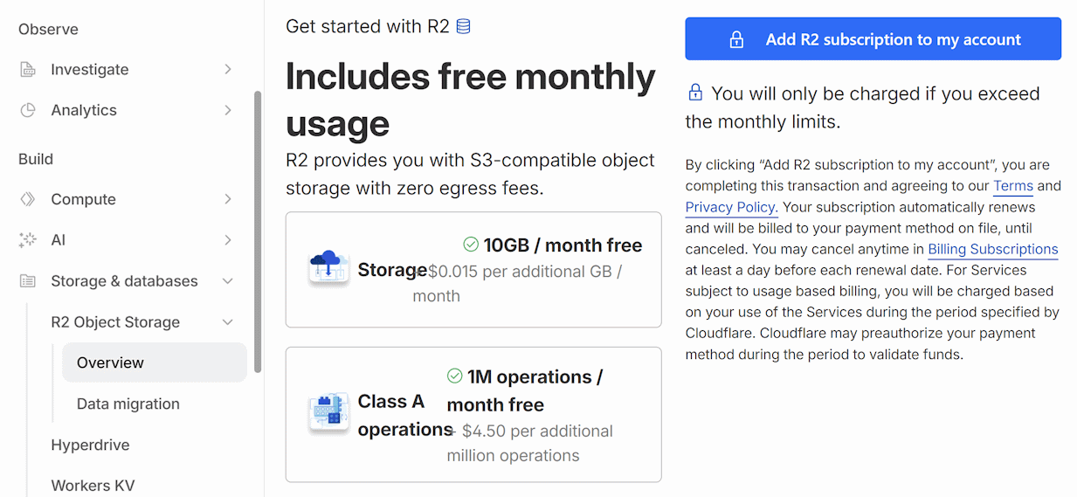

Register with a Debit Card
You may need to put a debit card to register for the service. To avoid unplanned payments, you can use a temporary debit card: create a new debit card in Revolut or Wise, then register in Cloudflare with this card, then delete / freeze the card in Revolut.

Create a Storage Bucket
Storage buckets are like "projects" inside your Cloudflare R2 account. You can use different buckets for different apps you build.
For the "Recipes" app, create a storage bucket called `recipes-photos`:
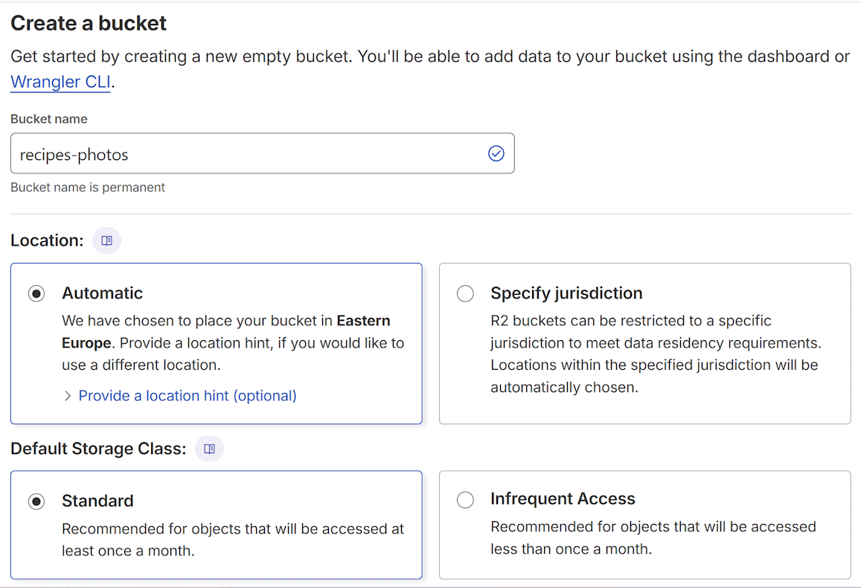

Create API Keys
Go out of the bucket section and scroll down to the [Manage] button:
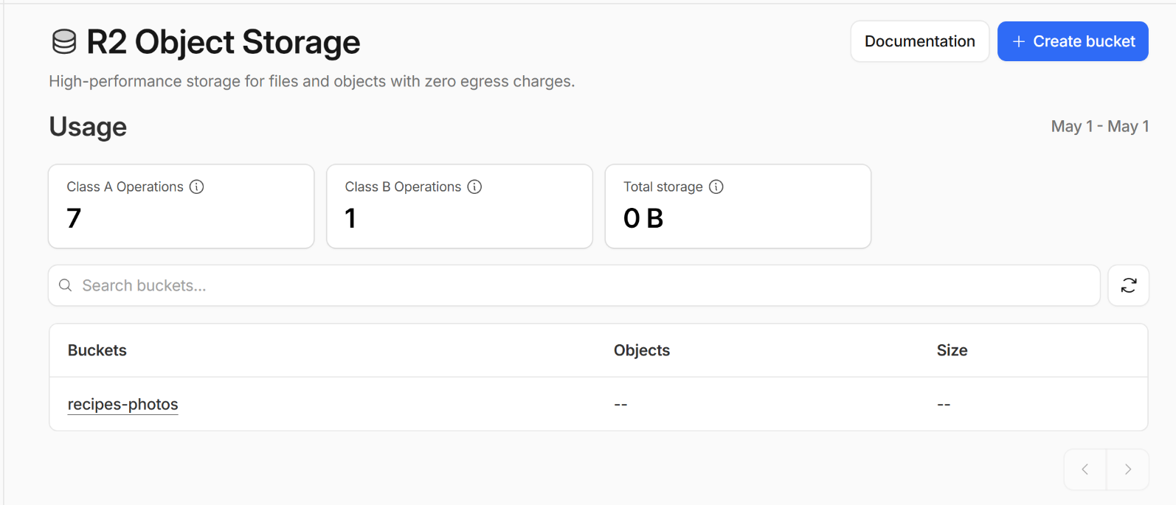
Then click the [Create Account API token] button:
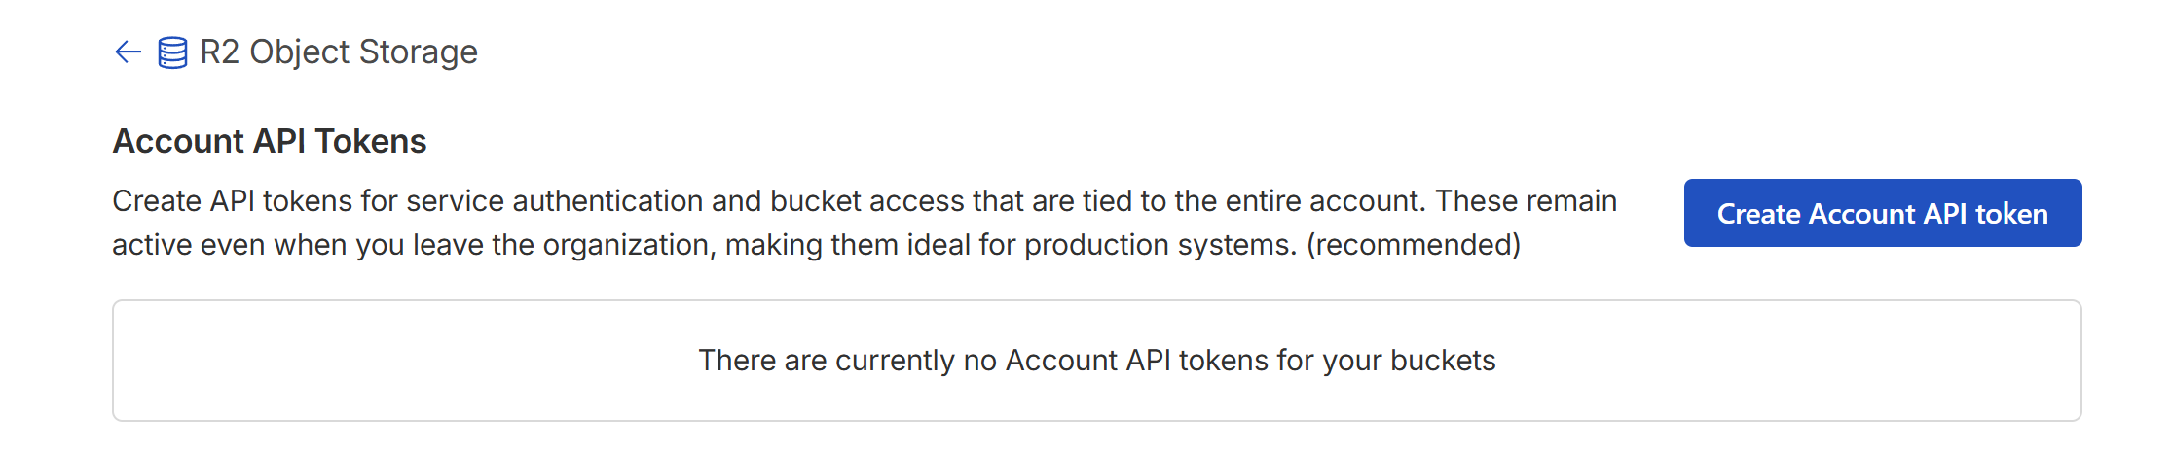
Select a proper name and [Object Read and Write]:
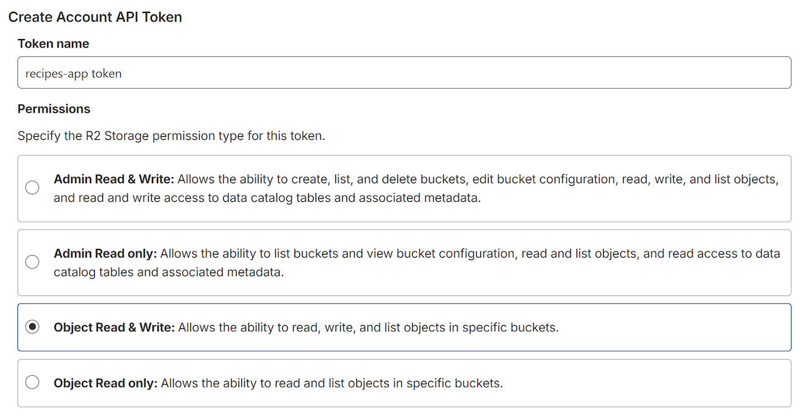
Make it apply to a specific bucket `recipes-photos`:
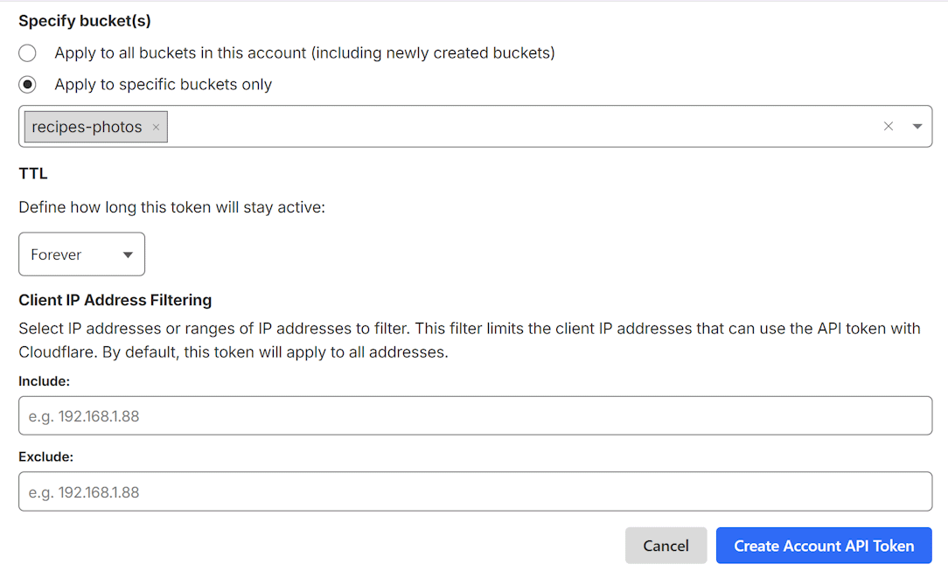
Caution: Write down ALL VALUES which will appear in the next step. They will be needed and WILL NOT BE SHOWN ANYWHERE ELSE.

Create a Public URL
Next, go to the `recipes-photos` bucket and click [Settings]:
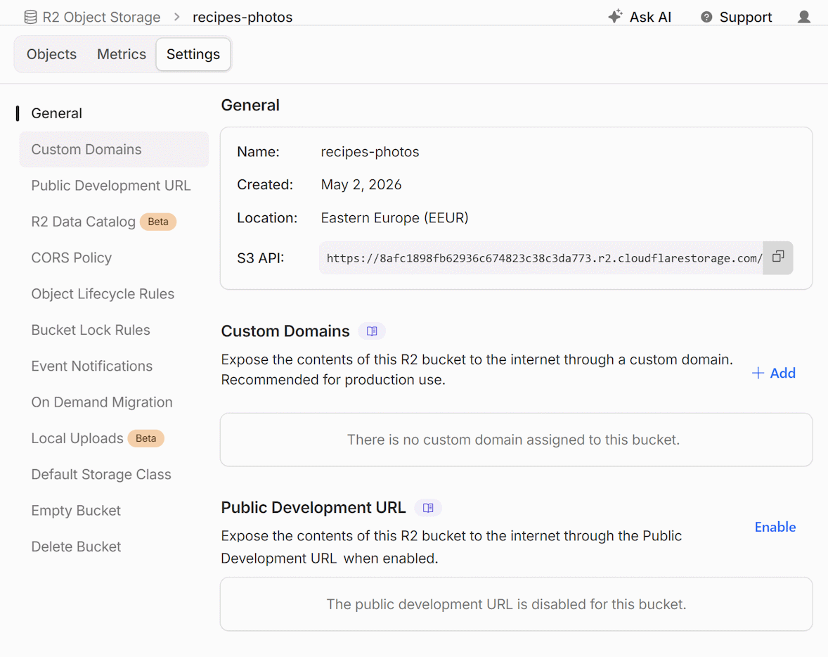
Click [Enable] for the Public Development URL and then type `allow` in the field that will appear:
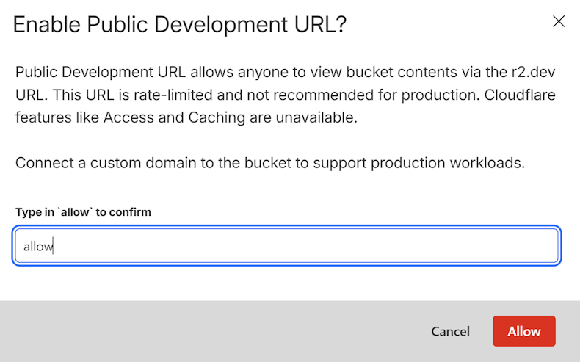
Write down the public URL that will appear when you click [Allow].

Step 2: Configure `.env` app secrets
Copy these templates and paste them in the `.env` file and fill in your keys and URLs:
R2_URL=https://<account_id>.r2.cloudflarestorage.com
R2_BUCKET=recipes-photos
R2_ACCESS_KEY_ID=<s3-access-key-id>
R2_SECRET_ACCESS_KEY=<s3-secret-access-key>
R2_PUBLIC_URL=https://pub-<url-id>.r2.dev
This is how the .env file may look when filled in:
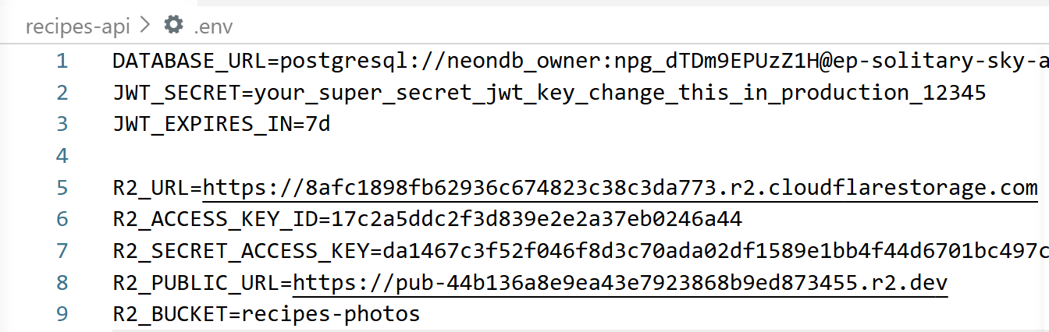

Step 3. Implement Photo Uploads
Implement cover-image uploads to the Recipes App. This is 3-step process, involving database changes, back-end changes and front-end changes:
- Add a `photo_url` column to the recipes table
  - Generate Drizzle migration + Drizzle migrate the DB
- Implement a backend endpoint `POST /api/recipes/:id/photo` that uploads a photo to Cloudflare R2. Return the public URL of the uploaded photo.
  - Upload the file to Cloudflare R2 using `@aws-sdk/client-s3`
  - Use R2 credentials from the .env configuration
- In the client app UI in the Create / Edit recipe pages
  - Add an image upload input with live preview + [Remove] button
  - Upload / delete the image on [Save]; remove image on [Delete Post]

Sample AI Prompt
You can implement photos in the Recipes apps with an AI prompt:
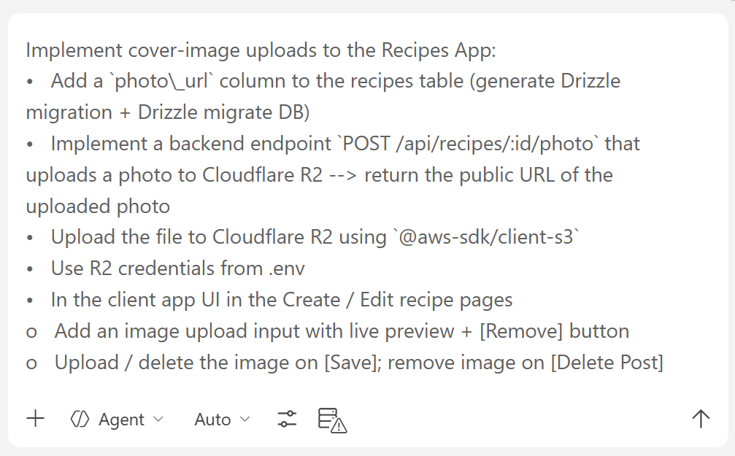

The Result: Recipes with Images
The result after the "photos upload" is implemented may look like the screenshots below.

Adding an Image to a Recipe
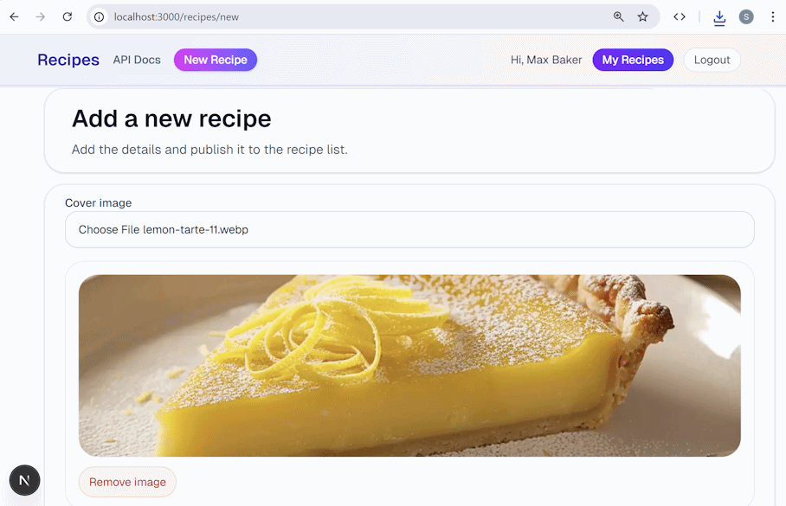

My Recipes Section
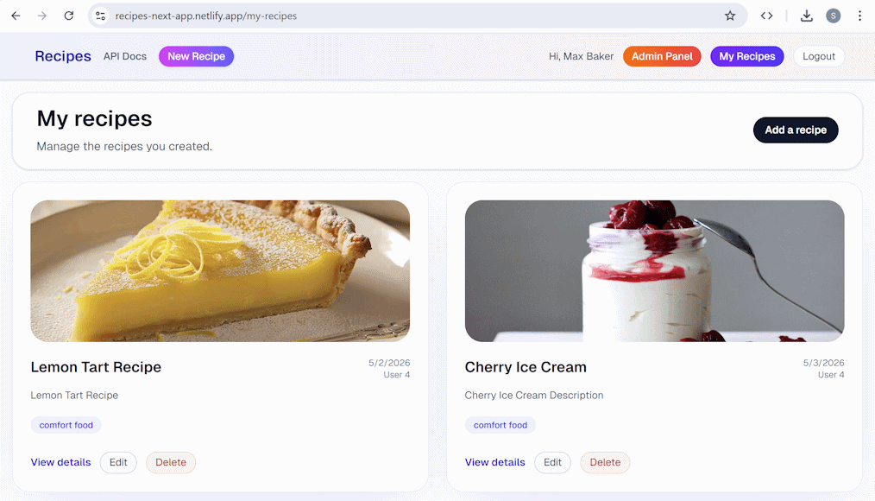

Recipes API Automated Tests
Add automated tests to the Recipes API project. We shall use AI prompts, because implementing tests by hand requires QA automation skills and experience.

Step 1. Jest Unit Tests
Unit tests are automated software tests, which verify that system components work as expected. They test only the components, in an isolated environment. Unit tests are fast and should have high coverage of the app features.
Implement unit tests for the Recipes System API:
- Install Jest (automated testing framework for JavaScript / TypeScript)
- Write unit tests for the core logic: password hashing, JWT token generation / verification
- Write unit tests for the validation logic (recipe fields, email format, etc.)
  - Mock external dependencies (DB, network, etc.).
  - Run the tests and measure code coverage.

Sample AI Prompt
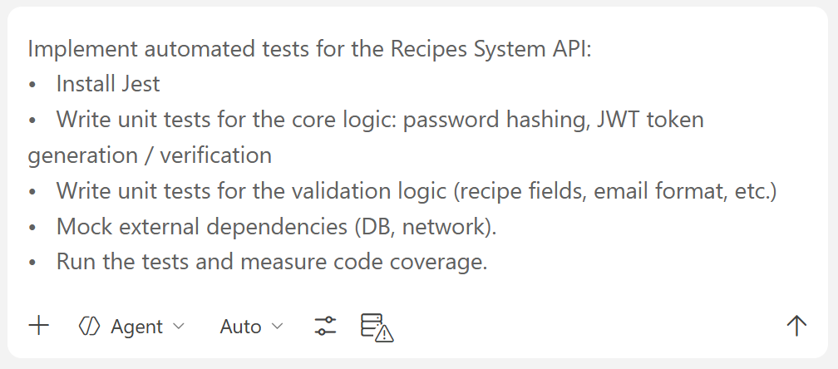

The Result: Unite Tests with Jest
You will see which tests pass successfully and which fail. You can run the tests with `npm run test`.
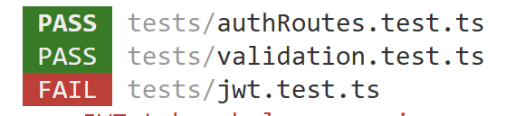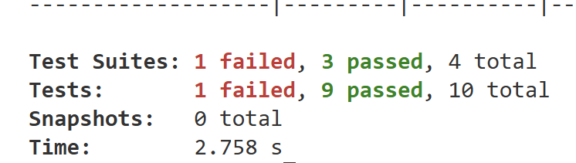

Step 2. Jest Integration Tests
In software systems, integration tests verify that software components interact correctly with each other, e.g. the API endpoints work correctly with the database. Integration tests are
Implement integration tests with Jest for the Recipes System API:
- Testing workflow: connect to test DB -> run Drizzle migrate -> empty all DB tables -> seed testing data -> run the integration tests
- Test all major endpoints: register, login, me, list, view, create, edit, delete posts, non-owner forbidden
- Perform real HTTP requests (not mocked)
- Write integration tests with real DB access:
  - Register / login flow
  - CRUD operations for recipes
  - Access control: a user cannot edit / delete another user's recipe; anonymous visitors cannot create / edit / delete recipes
- Work in a testing Neon database (connect by TEST_DATABASE_URL), not a mocked database
- Reset the test DB between before test runs (use Drizzle migrations + seed script)

Setup a Testing DB
We shall set up a testing DB in Neon, which will be used to perform the integration tests. It is important to use separate testing DB (not the production database), to avoid data loss. We shall reset the DB to a known initial state before running the integration tests. If we reset the production DB, we shall lose customer data.
Go to Neon and open the database for the Recipes App. Then select [Branches] from the side menu and click [New Branch]:
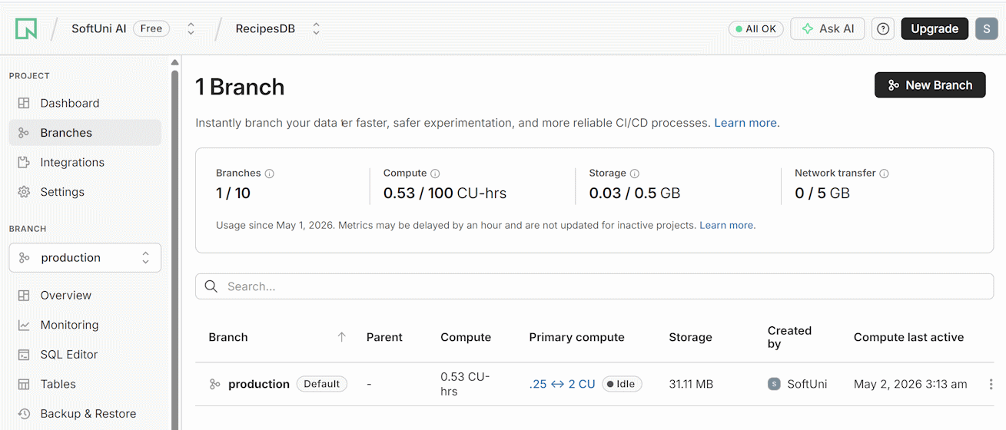
Set the branch like this and click [Create]:
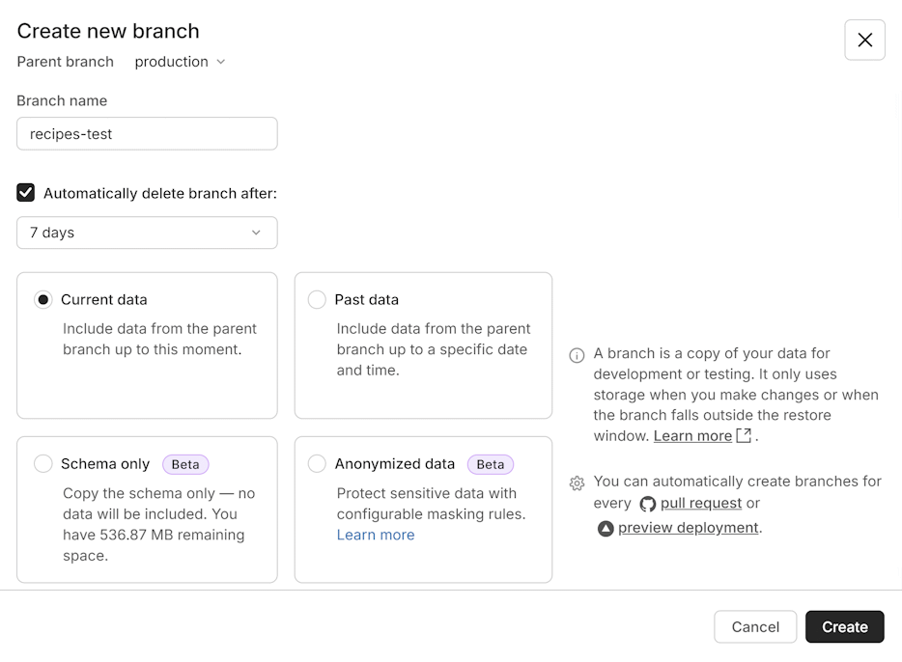
Copy the connection string for the testing DB in Neon:
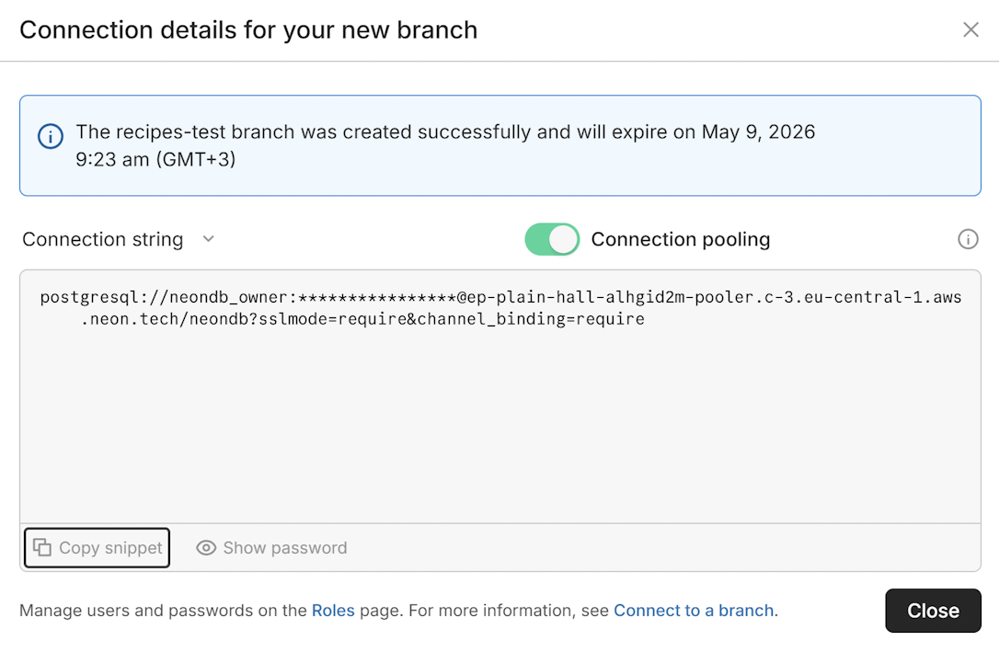
Put the connection string as new entry in the `.env` config:
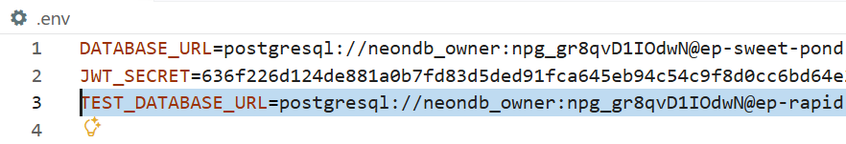

AI Prompt for Integration Tests
Run an AI prompt to implement the integration tests. A more skillful AI agent + underlying LLM will work better.
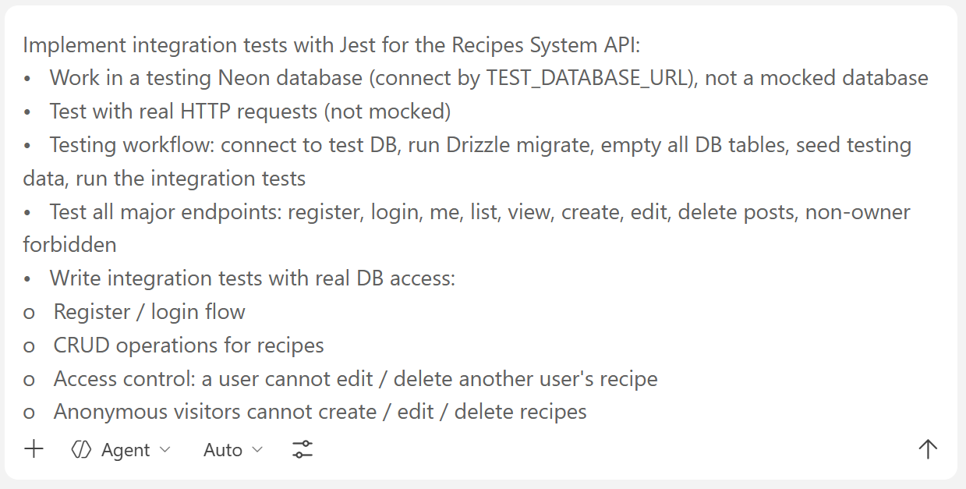
The AI dev agent will implement the integration tests for the Recipes API and will run them. You may probably get a message like this:
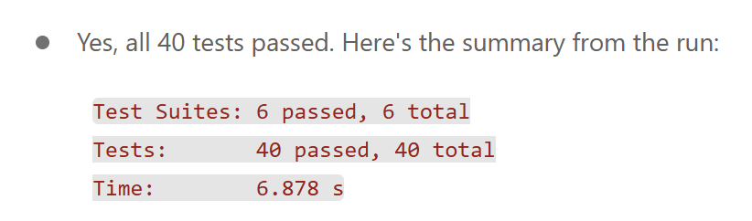

Step 3. E2E Tests with Playwright
Implement Playwright end-to-end tests for the Recipes client:
- Install Playwright to automate the interaction with the UI in the Web browser
- Write end-to-end tests for the main user flows:
  - Home page renders the expected number of posts
  - Anonymous user browses recipes and views details
  - User registers, logs in, creates a recipe, edits it, deletes it
  - User cannot see the "Edit" button on another user's recipe
- Run the tests against local dev server with a fresh seeded testing DB

Sample AI Prompt
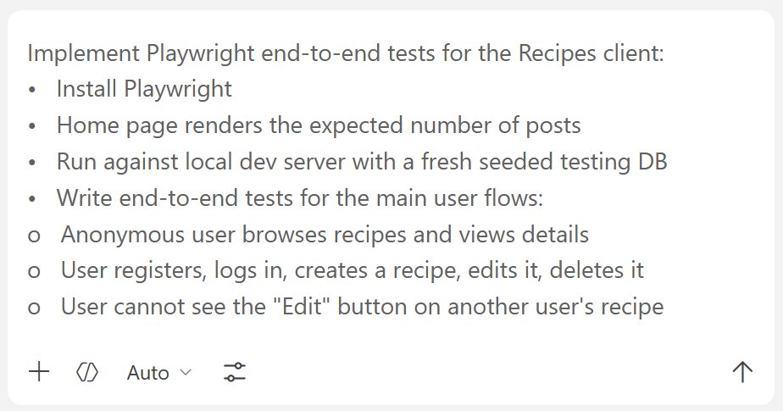

Recipes App in Netlify
Deploy the "Recipes" full-stack app (API + client) to Netlify.

Step 1. Publish to GitHub
Initialize a Git repo for this project:
- Create a `.gitignore` for Node + Next.js
- Commit the code in the local Git
- Create a GitHub repo "recipes-app" (private)
- Push the code to GitHub

Sample AI Prompt
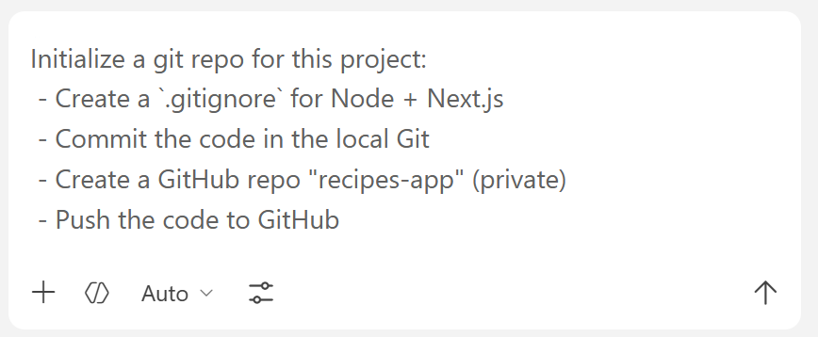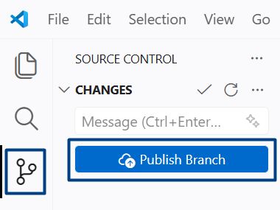

Step 2. Deploy from GitHub to Netlify
Go to Netlify -> [Add a New Project]:
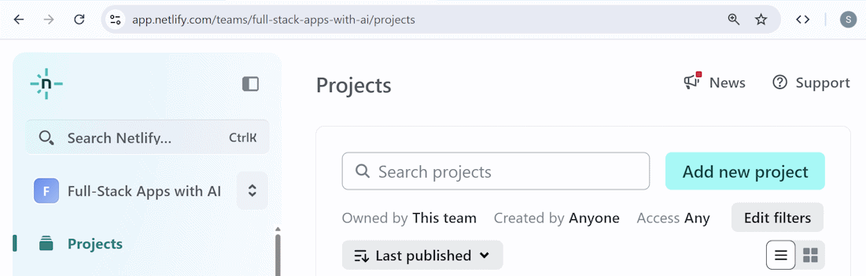
Select [GitHub] and Authorize:
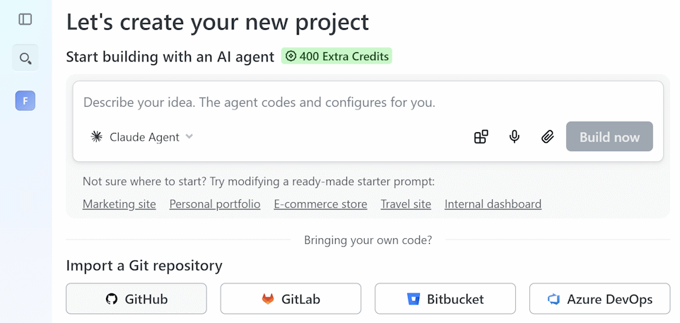
Select a Project name:
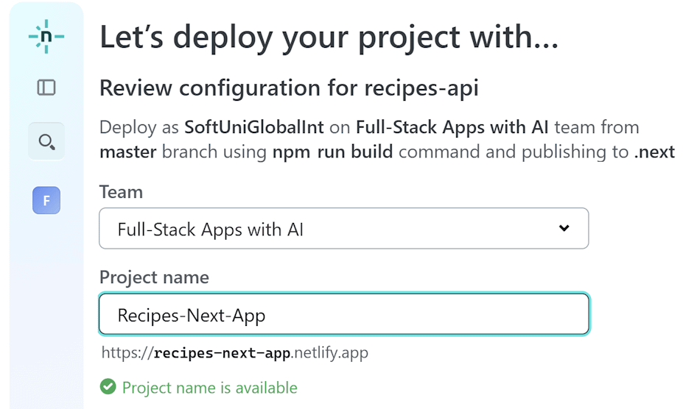
Scroll down to adding the environment variables and add them. Add ALL OF THE VARIABLES to the `.env` file, otherwise the website won’t work properly:
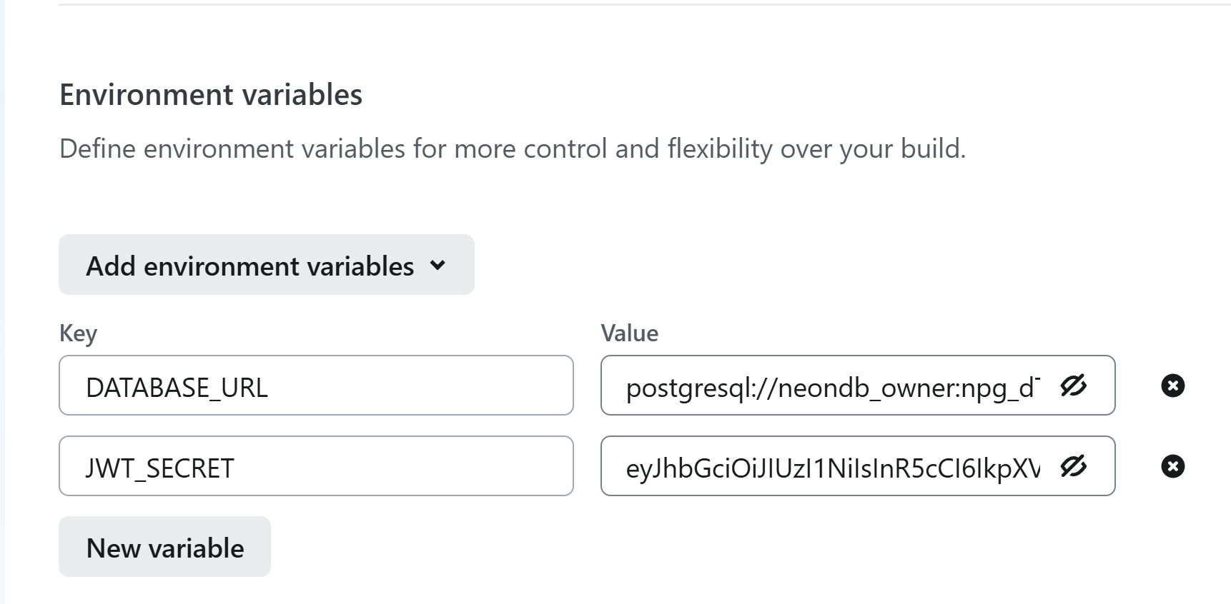
Proceed with the deployment and wait a bit. The application will be available in [Project overview]:
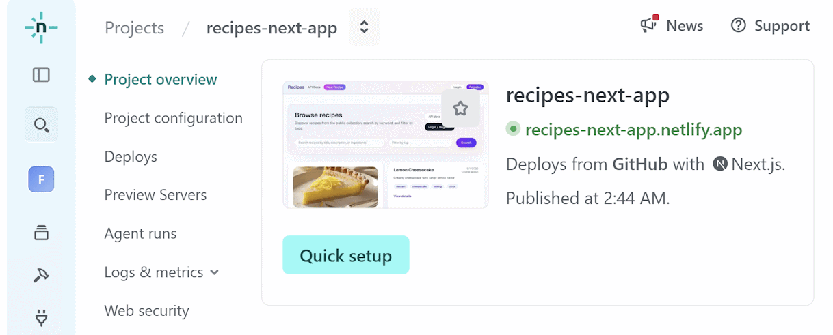

Bonus: Recipes Admin Panel
Implement Admin Panel in the Recipes app:
  - Implement admin users in the Recipes API
    - Add `is_admin` column to the users table (Drizzle migration)
    - The first admin will be promoted manually via SQL in Neon
  - Implement additional API endpoints for admins:
    - Manage all recipes (view / edit / delete any recipe)
    - Manage users (list / edit / delete / promote to admin)
  - In the client app implement an Admin Panel with two tabs:
    - Manage Recipes: view / edit / delete any recipe
    - Manage Users: view / edit / delete users, promote to admin
  - After user login, display [Admin Panel] link for admin users only

Sample AI Prompt
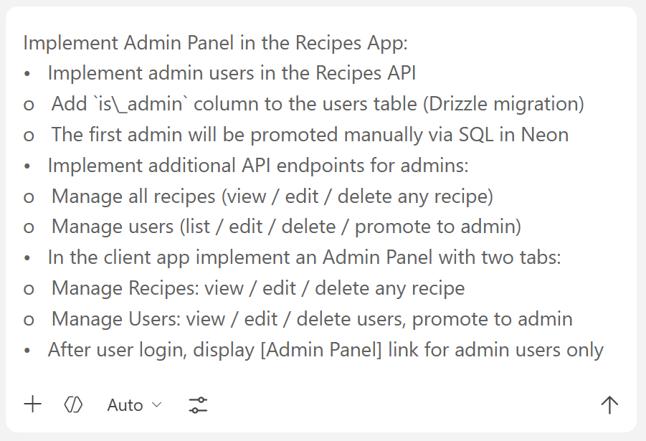

Create the First Admin
According to the exercise description, the first admin is expected to be created manually through the database.
We shall create the first admin user in Neon Table Editor. Open Neon Dashboards, open your database project, select the [Tables] menu and then double-click on the [FALSE] cell on the account you would like to promote. Select [TRUE] from the drop-down list:
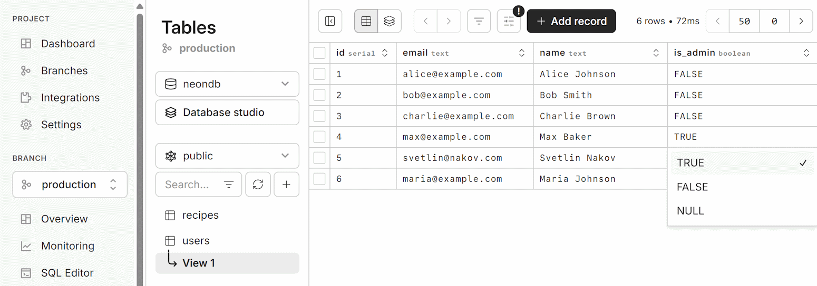

The Admin Panel
Once we have an admin user and the Admin Panel functionality implemented, we can login as admin and test the admin functionality.

Managing Recipes
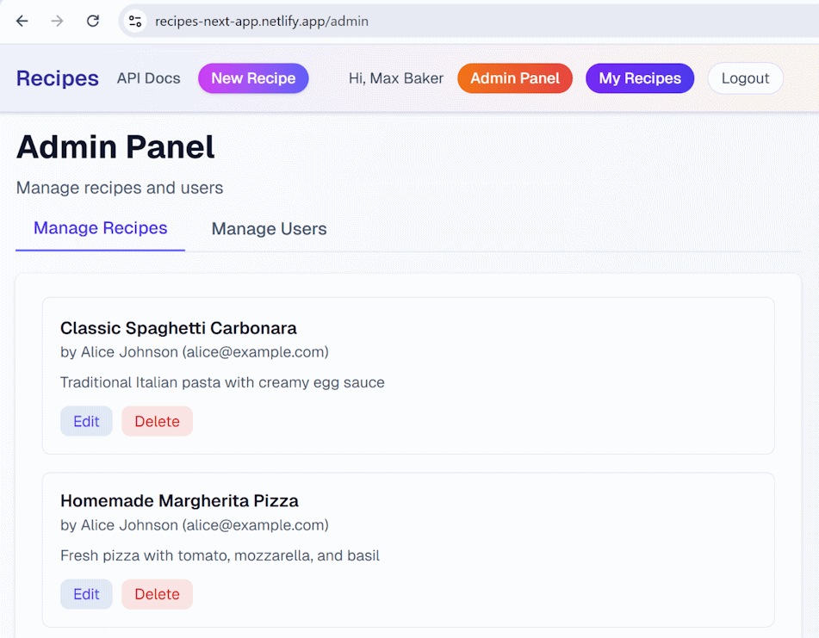

Managing Users
After the first admin has been added, the others should be editable though the admin user UI:
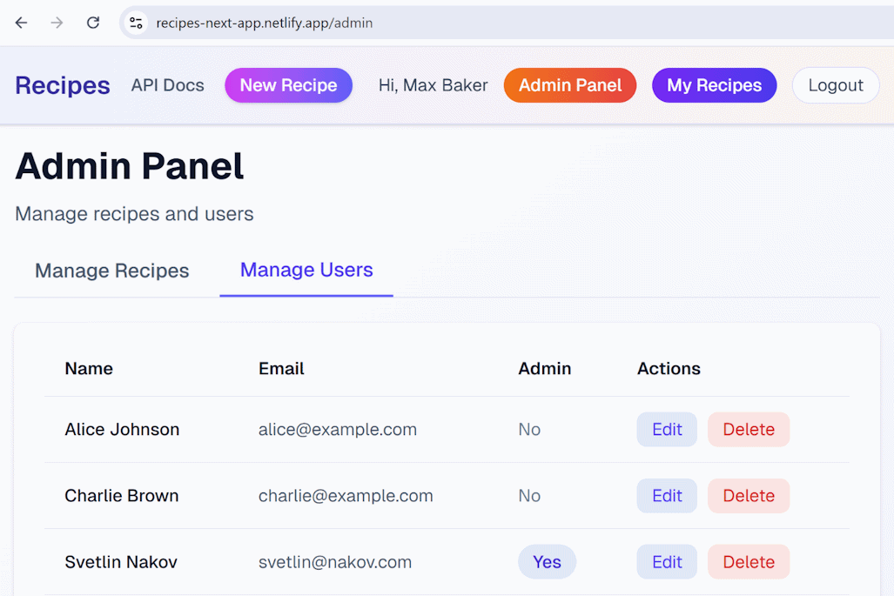
You can create new admin via the Admin Panel -> Manage Users:
